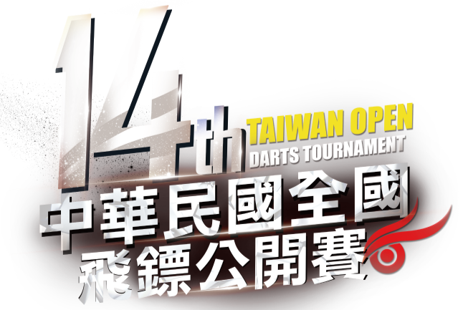

Index
1. Transportation Information (交通資訊) 2
1-1. Airport Hotel 2
Taoyuan International Airport 2
Taipei Songshan Airport 6
1-2. Tournament Hall 9
2. Hotel Info & Tour Guide (飯店與周邊生活資訊) 10
Other Shop’s Map Nearby Hotel (飯店周邊生活、商店路線圖) 16
3. Taoyuan City Tour (大桃園區觀光) 17
◎Downtown of Taoyuan City (桃園市區) 19
Taoyuan Airport MRT Map (桃園機場捷運路線圖) 23
4. Taipei City Tour (台北觀光) 24
Taipei MRT Map (台北捷運路線圖) 29
5. Dart Shop Information (鏢店資訊) 30
6. 14th Taiwan Open on Google Map(QR Code) 34
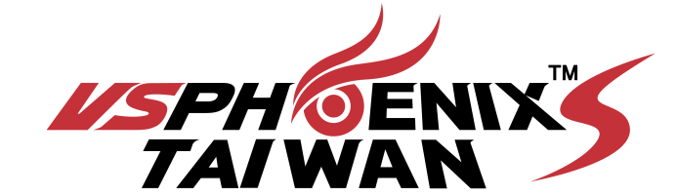

1. Transportation Information

1-1. Airport Hotel

Taoyuan International Airport
Arrival : Taoyuan Int’l Airport Four Points by Sheraton Linkou
(No. 1, Sec. 1, WenHua 3rd Rd., Linkou Dist., New Taipei City)
Option 1: MRT (Recommend)
Route | Ticketing and Service Location | Journey Time (approx.) | Service Hours | Fare
- Arrived Taoyuan Int’l Airport  - Take Taoyuan Airport MRT to “A9 Linkou” Station  - Walk to “Four Points by Sheraton Linkou” just opposite to the station. | Ticketing: Buy ticket at “Airport Terminal 1” or “Airport Terminal 2” | 30 mins | 06:00 am - 00:00 am | NT$60
For more information, please visit: http://www.taoyuan-airport.com/english/Buses/
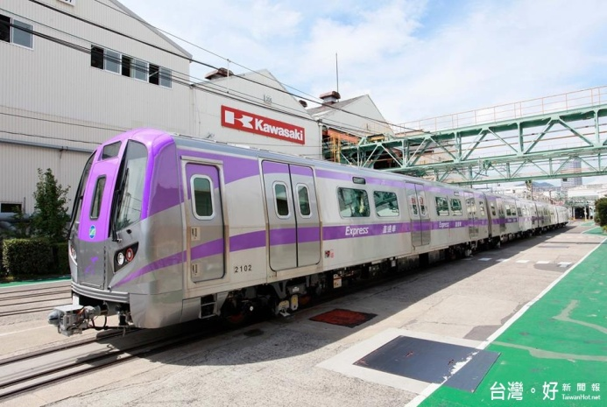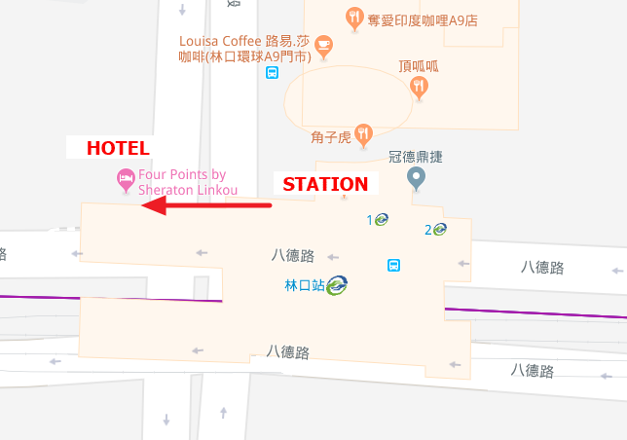
Option 2: Taxi (High Recommend)
Route | Pickup Location | Journey Time (approx.) | Service Hours | Fare
- Arrived Taoyuan Int’l Airport  - Walking to airport taxi station  - Take taxi to “Four Points by Sheraton Linkou”  (Max. 4 passengers) | Terminal 1 Taxi pickup point:  Located at the west side of Arrivals hall Gate 12  Terminal 2 Taxi pickup point  Located at the west side of Arrivals hall Gate 21 | 20-30 mins | 24 hours and 365 days | NT$700-  800 (per trip)  *based on the meter
For more information, please visit: http://www.taoyuan-airport.com/english/taxi

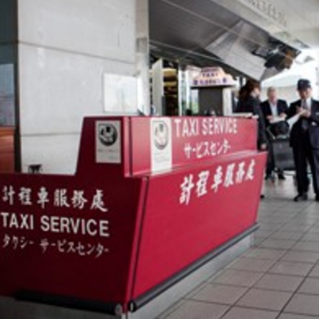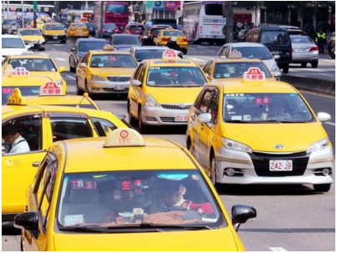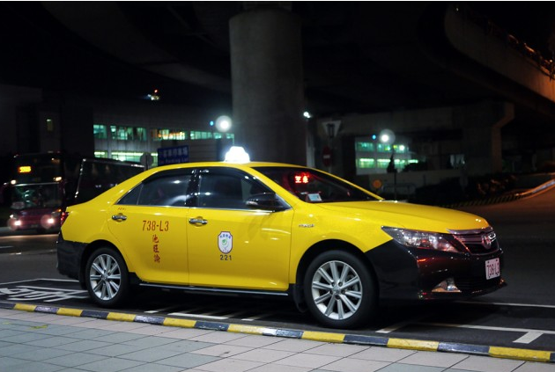
Option 3: Car Rental and Hotel Parking
Route | Car rental service and parking location | Journey Time (approx.) | Service Hours | Fare
- Arrived Taoyuan Int’l Airport  - Walking to car rental service counter  - Rent a car  - Set GPS and drive towards hotel at New Taipei city  - Park the car at “Four Points by Sheraton Linkou” | Terminal 1 Car rental service:  Ching Bing Auto Leasing Co., Ltd., located at west side of the Arrivals hall  Terminal 2 Car rental service:  Hotai Leasing Corporation, located at west side of the Arrivals hall at 1st floor  Parking: “Four Points by Sheraton Linkou” offers 60 guest’s car parking | 20-30 mins | 06:00 am - 00:30 am  05:00 am - 12:00 am  24 hours | NT$2400 – 4200 per day  NT$2400 – 4500 per day  Room guests can enjoy free parking for one vehicle per room
For more information, please visit: http://www.taoyuan-airport.com/english/car-rentals
For car rental service companies information, please visit:
Ching Bing: http://www.chingbing.com.tw/index.php
Hotai: https://www.easyrent.com.tw/English/index.html
Departure : Four Points by Sheraton Linkou Taoyuan International Airport

Option 1: MRT (Recommend)
Route | Ticketing Location | Journey Time (approx.) | Service Hours | Fare
- Walk to Linkou Station from hotel.  - Purchase tickets to Taoyuan Int’l Airport at station  - Get off at either Terminal 1 or Terminal 2 at Taoyuan Int’l Airport | Ticketing: Tickets sell at MRT station | 30 mins | 06:00 am - 00:00 am | NT$60
For more information, please visit: http://www.taoyuan-airport.com/english/Buses/

Option 2: Taxi ( High Recommend)
Route | Pickup Location | Journey Time (approx.) | Service Hours | Fare
- Call taxi by hotel  - Get off at either Terminal 1 or Terminal 2 at Taoyuan Int’l Airport | Pickup location: Four Points by Sheraton Linkou | 20-30 mins | 24 hours and 365 days | NT$700 - 800 (per trip)  *based on the meter
For more information, please visit: http://www.taoyuan-airport.com/english/taxi

Taipei Songshan Airport
Arrival : Taipei Songshan Airport Four Points by Sheraton Linkou
Option 1: MRT ( Non – recommend )
Route | Ticketing Location | Journey Time (approx.) | Service Hours | Fare
- Arrived Taipei Songshan Airport  - Walking to MRT Songshan Airport Station  - Buy ticket to MRT Sanchong Station  - Walking to #1 BR-Line Platform towards MRT Taipei Zoo direction and take the subway  - Get off at Nanjing Fuxing Station and transfer to G-Line towards MRT Xindian direction  - Get off at Songjiang Nanjing Station and transfer to O-Line towards MRT Huilong direction  - Get off at Sanchong Station and transfer to Taoyuan Airport MRT  - Get off at A9 Linkou Station.  - Walk to the hotel just opposite to the station. | Ticketing: Tickets selling at MRT Songshan Airport Station, and station is located at the south side of Terminal 1 and 2 of Songshan Airport | 70 mins | 06:02 am - 00:43 am | NT$90
For more information, please visit: http://english.metro.taipei/
Option 2: Taxi ( Recommend )
Route | Pickup Location | Journey Time (approx.) | Service Hours | Fare
- Arrived Taipei Songshan Airport  - Walking to airport taxi station  - Take taxi to hotel  - Get off at Four Points by Sheraton Linkou | Pickup location: Taxi service station is located at south side exit of Terminal 1 of Taipei Songshan Airport | 30 mins | 24 hours and 365 days | Around NT$800-10,00 (per trip)  *based on the meter
For more information, please visit: http://www.tsa.gov.tw/tsa/en/page.aspx?id=1062

Departure : Four Points by Sheraton Linkou Taipei Songshan Airport
Option 1 : MRT ( Non – recommend )
Route | Ticketing Location | Journey  Time (approx.) | Service Hours | Fare
- Walk to Linkou Station  - Buy ticket to MRT Sanchung Station  - Get off at Sanchung Station and Walk to O-Line and take subway toward Nanshijiao Station direction  - Get off at Songjiang Nanjing Station and transfer to G-Line towards MRT Songshan direction  - Get off at Nanjing Fuxing Station and transfer to BR-Line towards MRT Taipei Nangang Exhibition Center direction  - Get off at MRT Songshan Airport Station | Ticketing: Tickets selling at MRT Linkou Station | 70 mins | 06:02 am - 00:43 am | NT$90
For more information, please visit: http://english.metro.taipei/

Option 2: Taxi (Recommend)
Route | Pickup Location | Journey Time (approx.) | Service Hours | Fare
- Call taxi by hotel  - Get off at either Terminal 1 or Terminal 2 at Taipei Songshan Airport | Pickup location: Four Points by Sheraton Linkou | 30 mins | 24 hours a day and 365 days | Around NT$800-1,000  *based on the meter
For more information, please visit: http://www.taoyuan-airport.com/english/taxi

1-2. Tournament Hall
National Taiwan Sport University Arena
No. 250, WenHua 1st Rd., Guishan Dist., Taoyuan City , Taiwan
Transport Information：Take Taoyuan Airport MRT to “National Taiwan Sport University Station” Exit 1 and walk to arena about 10 mins.
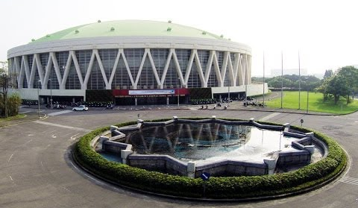
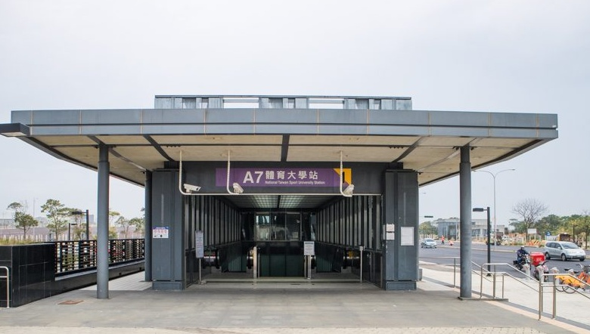
･ Hotel -> Tournament Hall ( Free Shuttle Bus )
Route | Time Schedule | Pickup Location
Hotel to Venue | Oct 5 & 6  AM 07:30, AM 07:50 | Front Door of Hotel
Venue to Hotel | Oct 5 & 6  PM 21:00, PM 22:00 | Front Door of Venue

2. Hotel Info & Tour Guide (飯店與周邊生活資訊)
林口亞昕福朋喜來登酒店 (Four Points by Sheraton Linkou)
新北市林口區文化三路一段1號
No. 1, Sec. 1, Wenhua 3rd Rd., Linkou Dist., New Taipei City
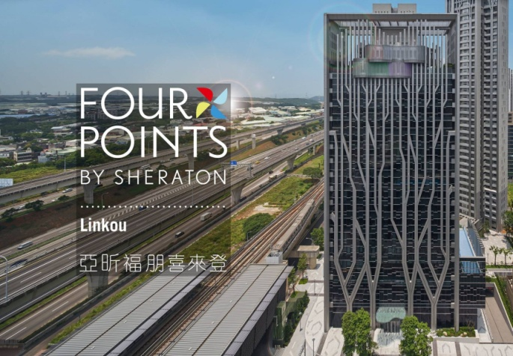 | 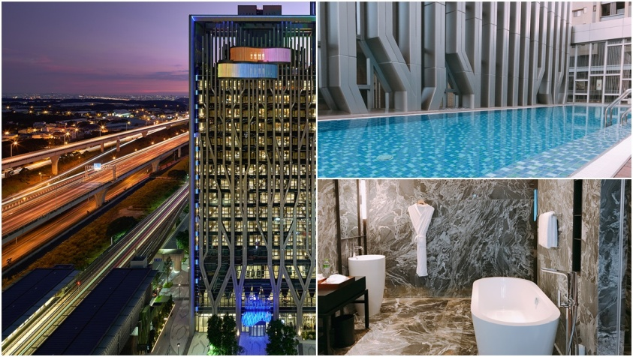

･購物(Shopping)、餐廳(Restaurant)、小吃(Snack)、飛鏢(Dart)

林口三井OUTLET(MITSUI OUTLET PARK) 11:00-22:00
新北市林口區文化三路一段356號
No. 356, Sec. 1, Wenhua 3rd Rd., Linkou Dist., New Taipei City
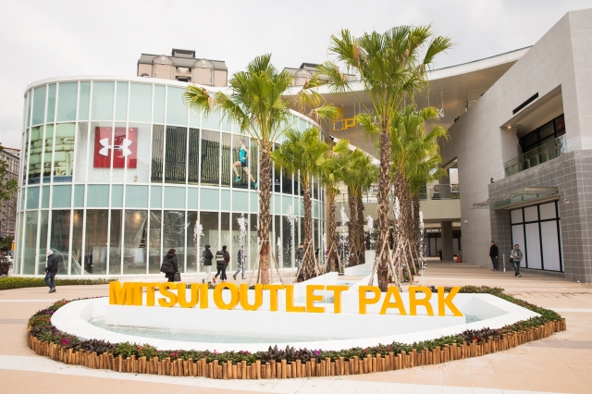 | 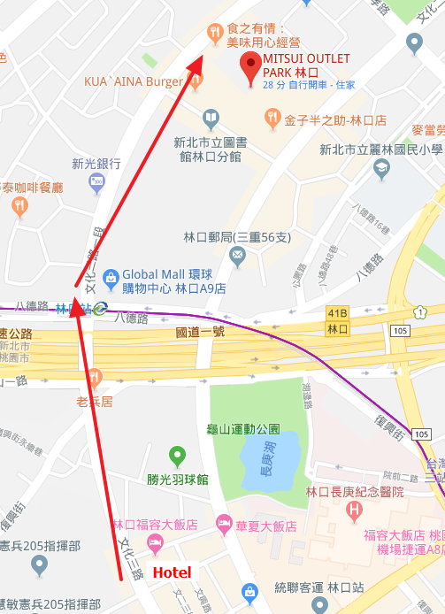

環球購物中心-林口(Global Mall A9) 11:00-22:00
新北市林口區文化三路一段2號
No. 2, Sec. 1, Wenhua 3rd Rd., Linkou Dist., New Taipei City
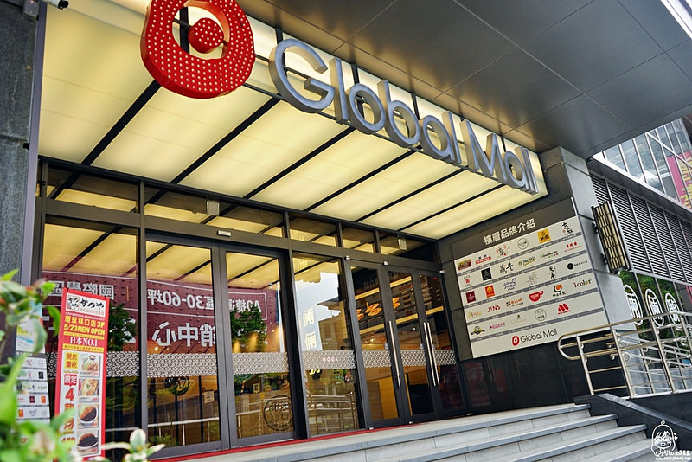 | 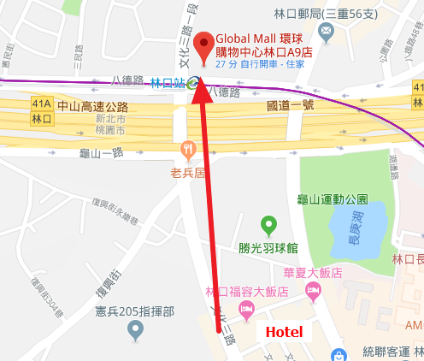

牛角坡早餐店(NIUJIAOPO) 06:00-12:00
桃園市龜山區文化一路86-30號
No. 86-30, Wenhua 1st Rd., Guishan Dist., Taoyuan City
TEL: +886 3 327 0198
Taiwan Style Breakfast
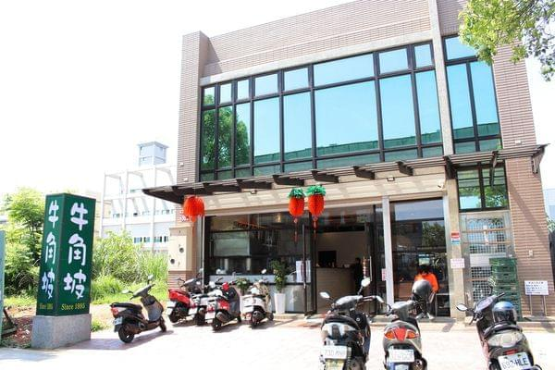 | 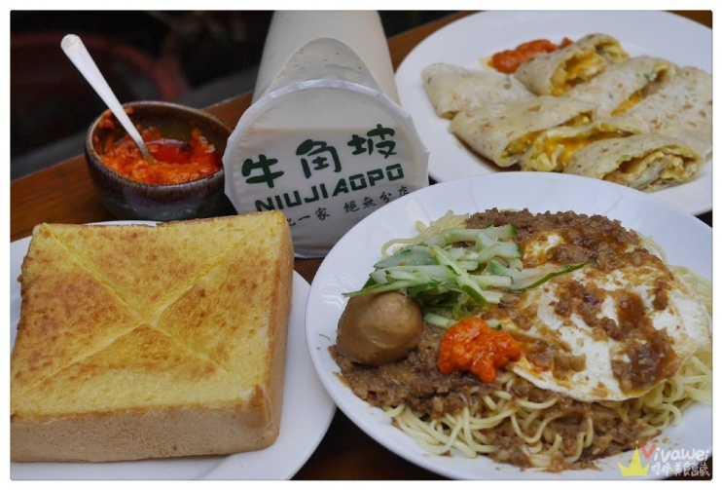
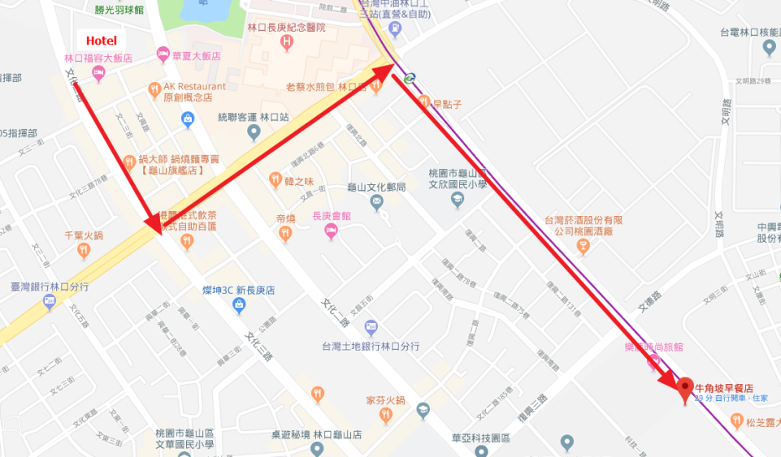

50嵐(50 Lan) 10:00-22:00
桃園市龜山區復興一路282號
No. 282, Fuxing 1st Rd., Guishan Dist., Taoyuan City
TEL: +886 3 211 5522
Famous Taiwan “Bubble Tea”
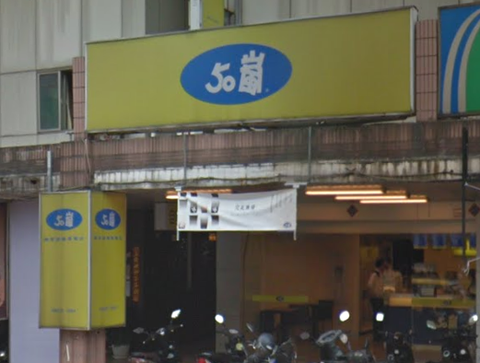  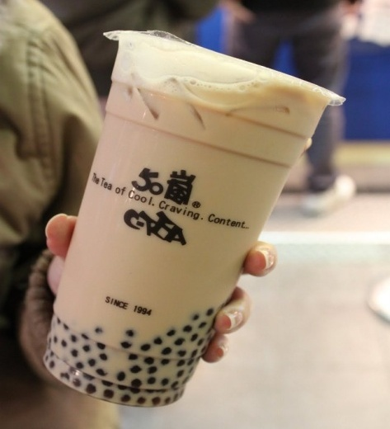 | 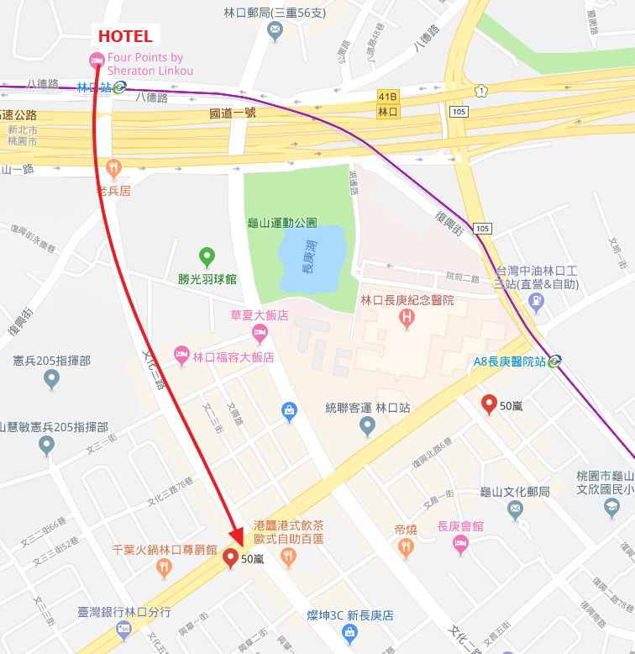

Cheers 乾杯吧(Cheers Linkou Restaurant Bar & Grill) 17:00-23:00
新北市林口區文化三路二段41巷2號
No. 2, Lane 41, Sec. 2, Wenhua 3rd Rd., Linkou Dist., New Taipei City
TEL: +886 2 2600 8664
American Style Restaurant with Beer and Dart.
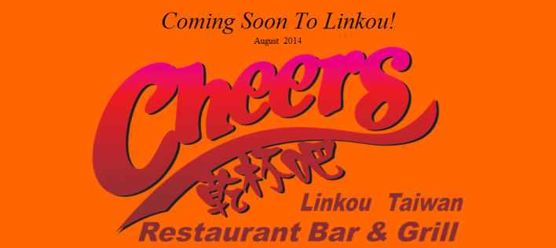 | 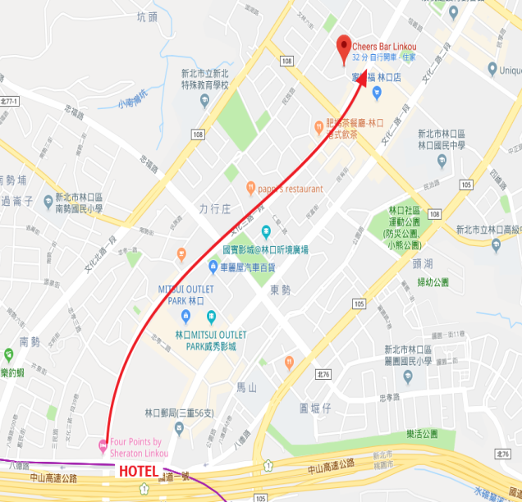
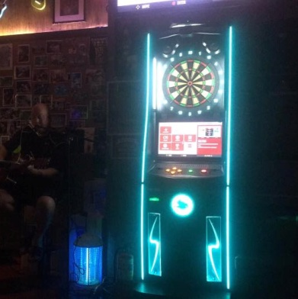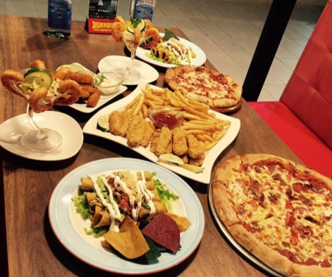

達樂釣蝦休閒廣場(Dollar Shrimp Fishing) 24 hours
新北市林口區文化北路一段127號
No. 127, Sec. 1, Wenhua N. Rd., Linkou Dist., New Taipei City
TEL: +886 2 2606 8188
Special “Shrimp Fishing” entertainment in Taiwan + Phoenixdart!!
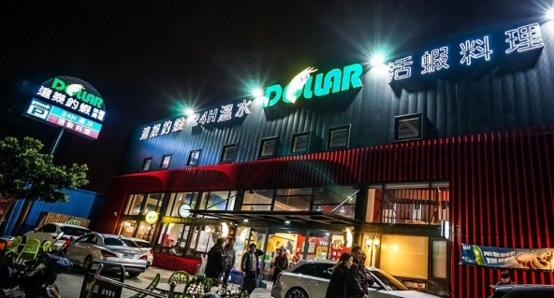 | 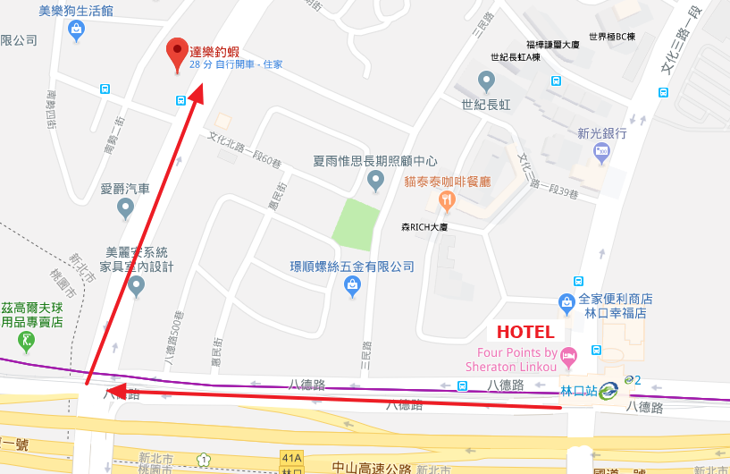
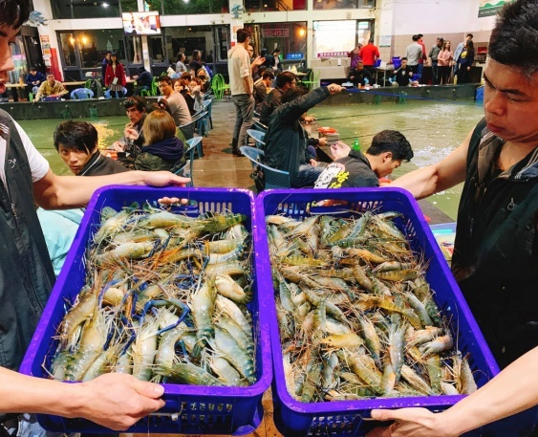

老四川-巴蜀麻辣燙(Old-Sichuan Spicy Hot Pot) 11:00-01:00
新北市林口區文化三路一段125號
No. 125, Sec. 1, Wenhua 3rd Rd., Linkou Dist., New Taipei City
TEL: +886 2 2608 8283
Taiwan Famous Spice Hot Pot.
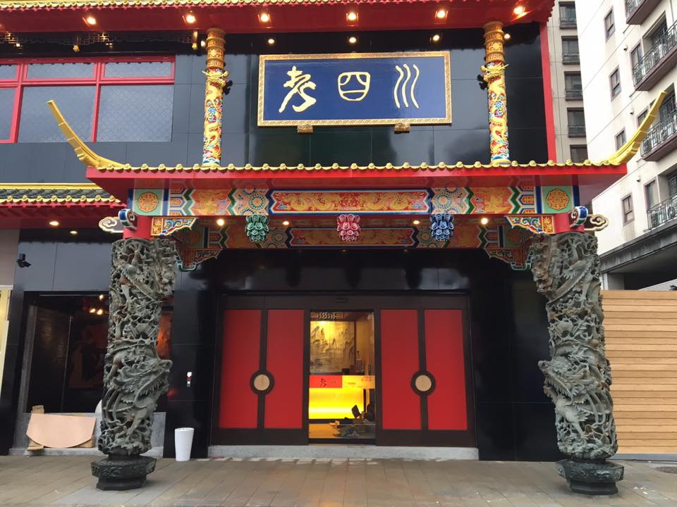  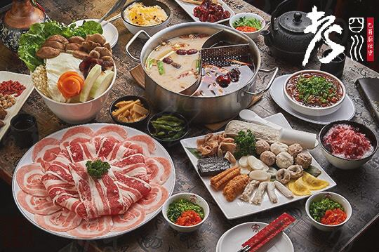 | 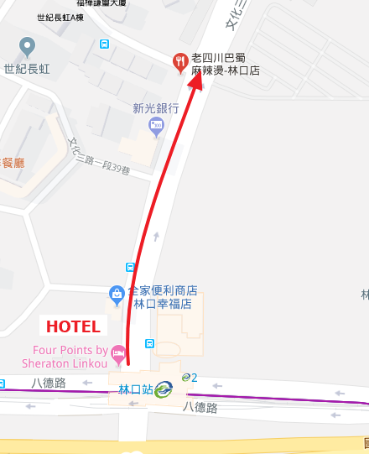

Nika Bar 21:00-04:00
桃園市龜山區文化二路34巷14弄23號
No. 23, Alley 14, Lane 34, Wenhua 2nd Rd., Guishan Dist., Taoyuan City
TEL: +886 3 318 2228
Dart Bar
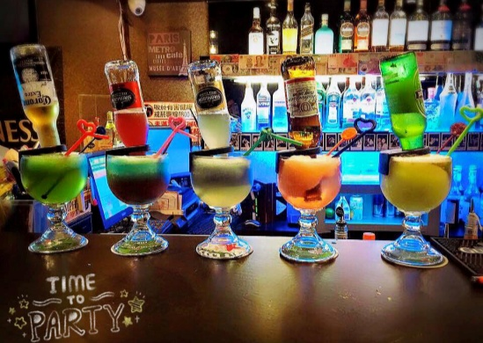 | 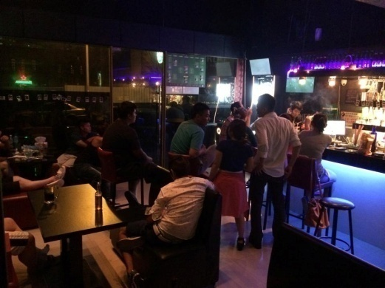
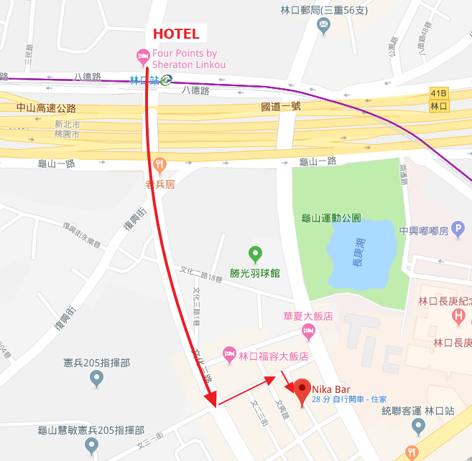

零玖Bar(09 Bar) 20:30-02:00
新北市林口區文化二路二段110巷16號
No. 16, Lane 110, Sec. 2, Wenhua 2nd Rd., Linkou Dist., New Taipei City
TEL: +886 2 2603 3309
Dart Bar
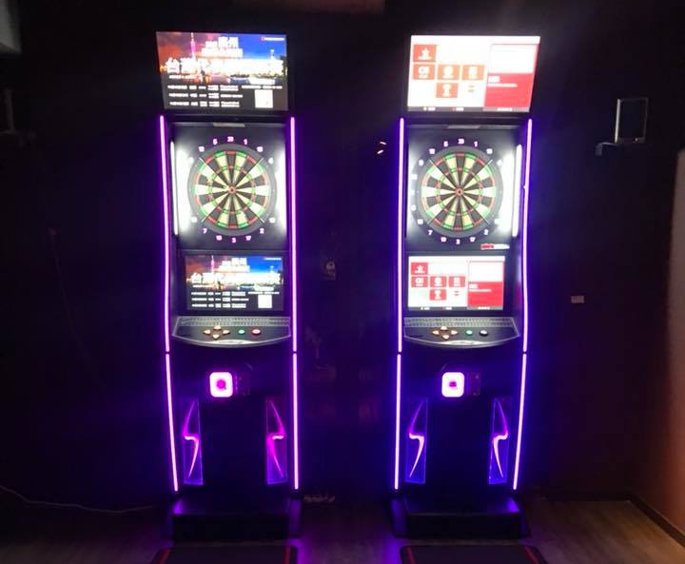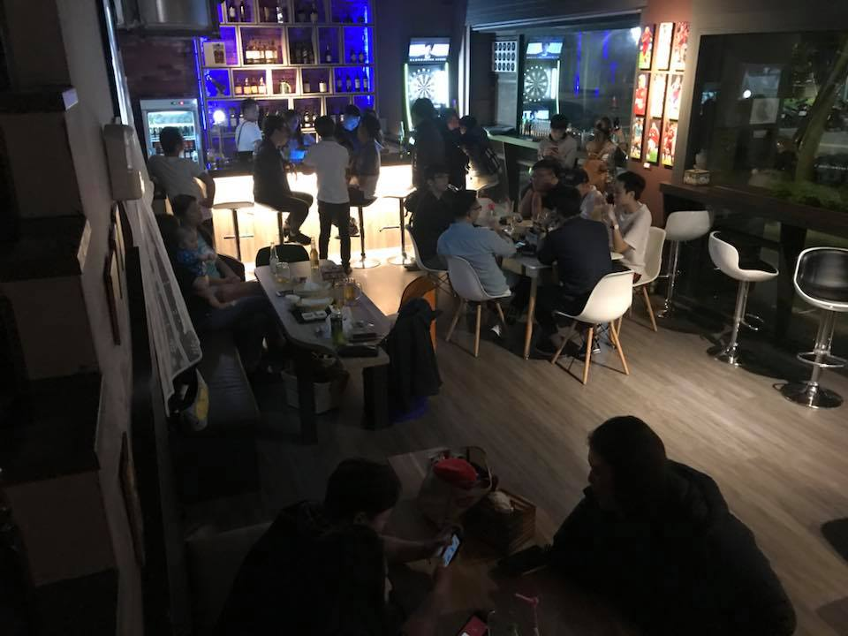 | 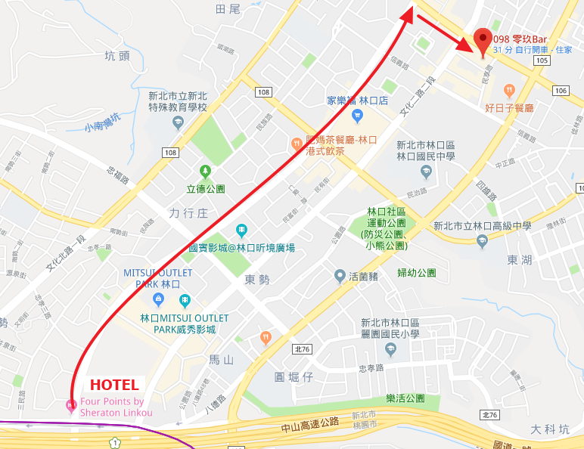

林口文化花園夜市(Linkou Night Market)
17:00-00:00(Thursday to Sunday Only)
桃園市龜山區龜山一路168號
No. 168, Guishan 1st Rd., Guishan Dist., Taoyuan City
Traditional Night Market
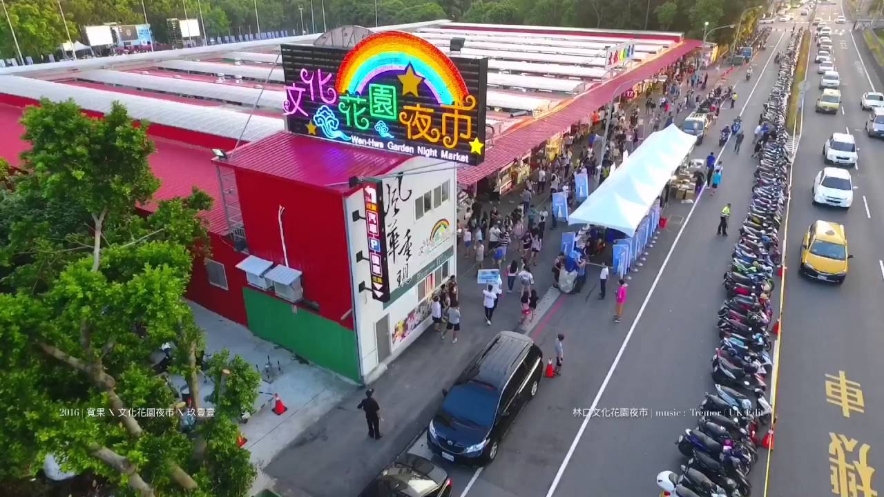
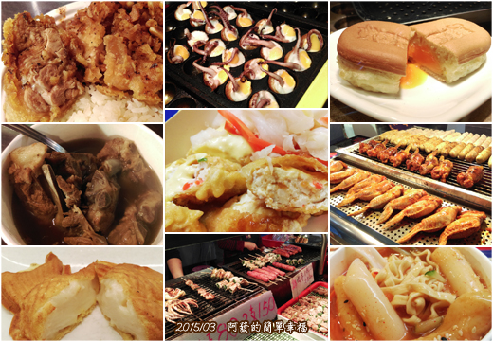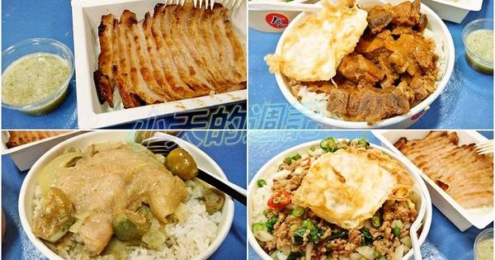
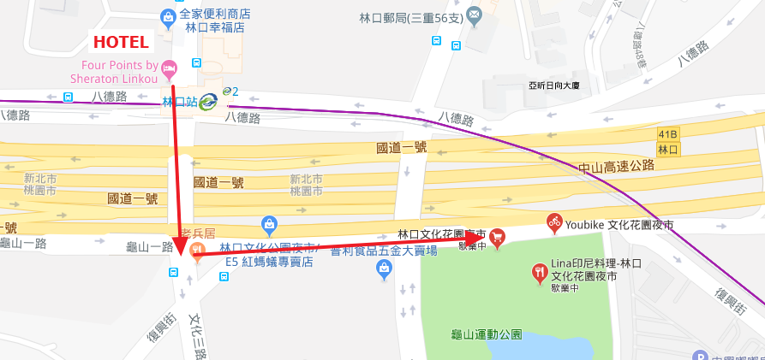

Other Shop’s Map Nearby Hotel(飯店周邊生活、商店路線圖)

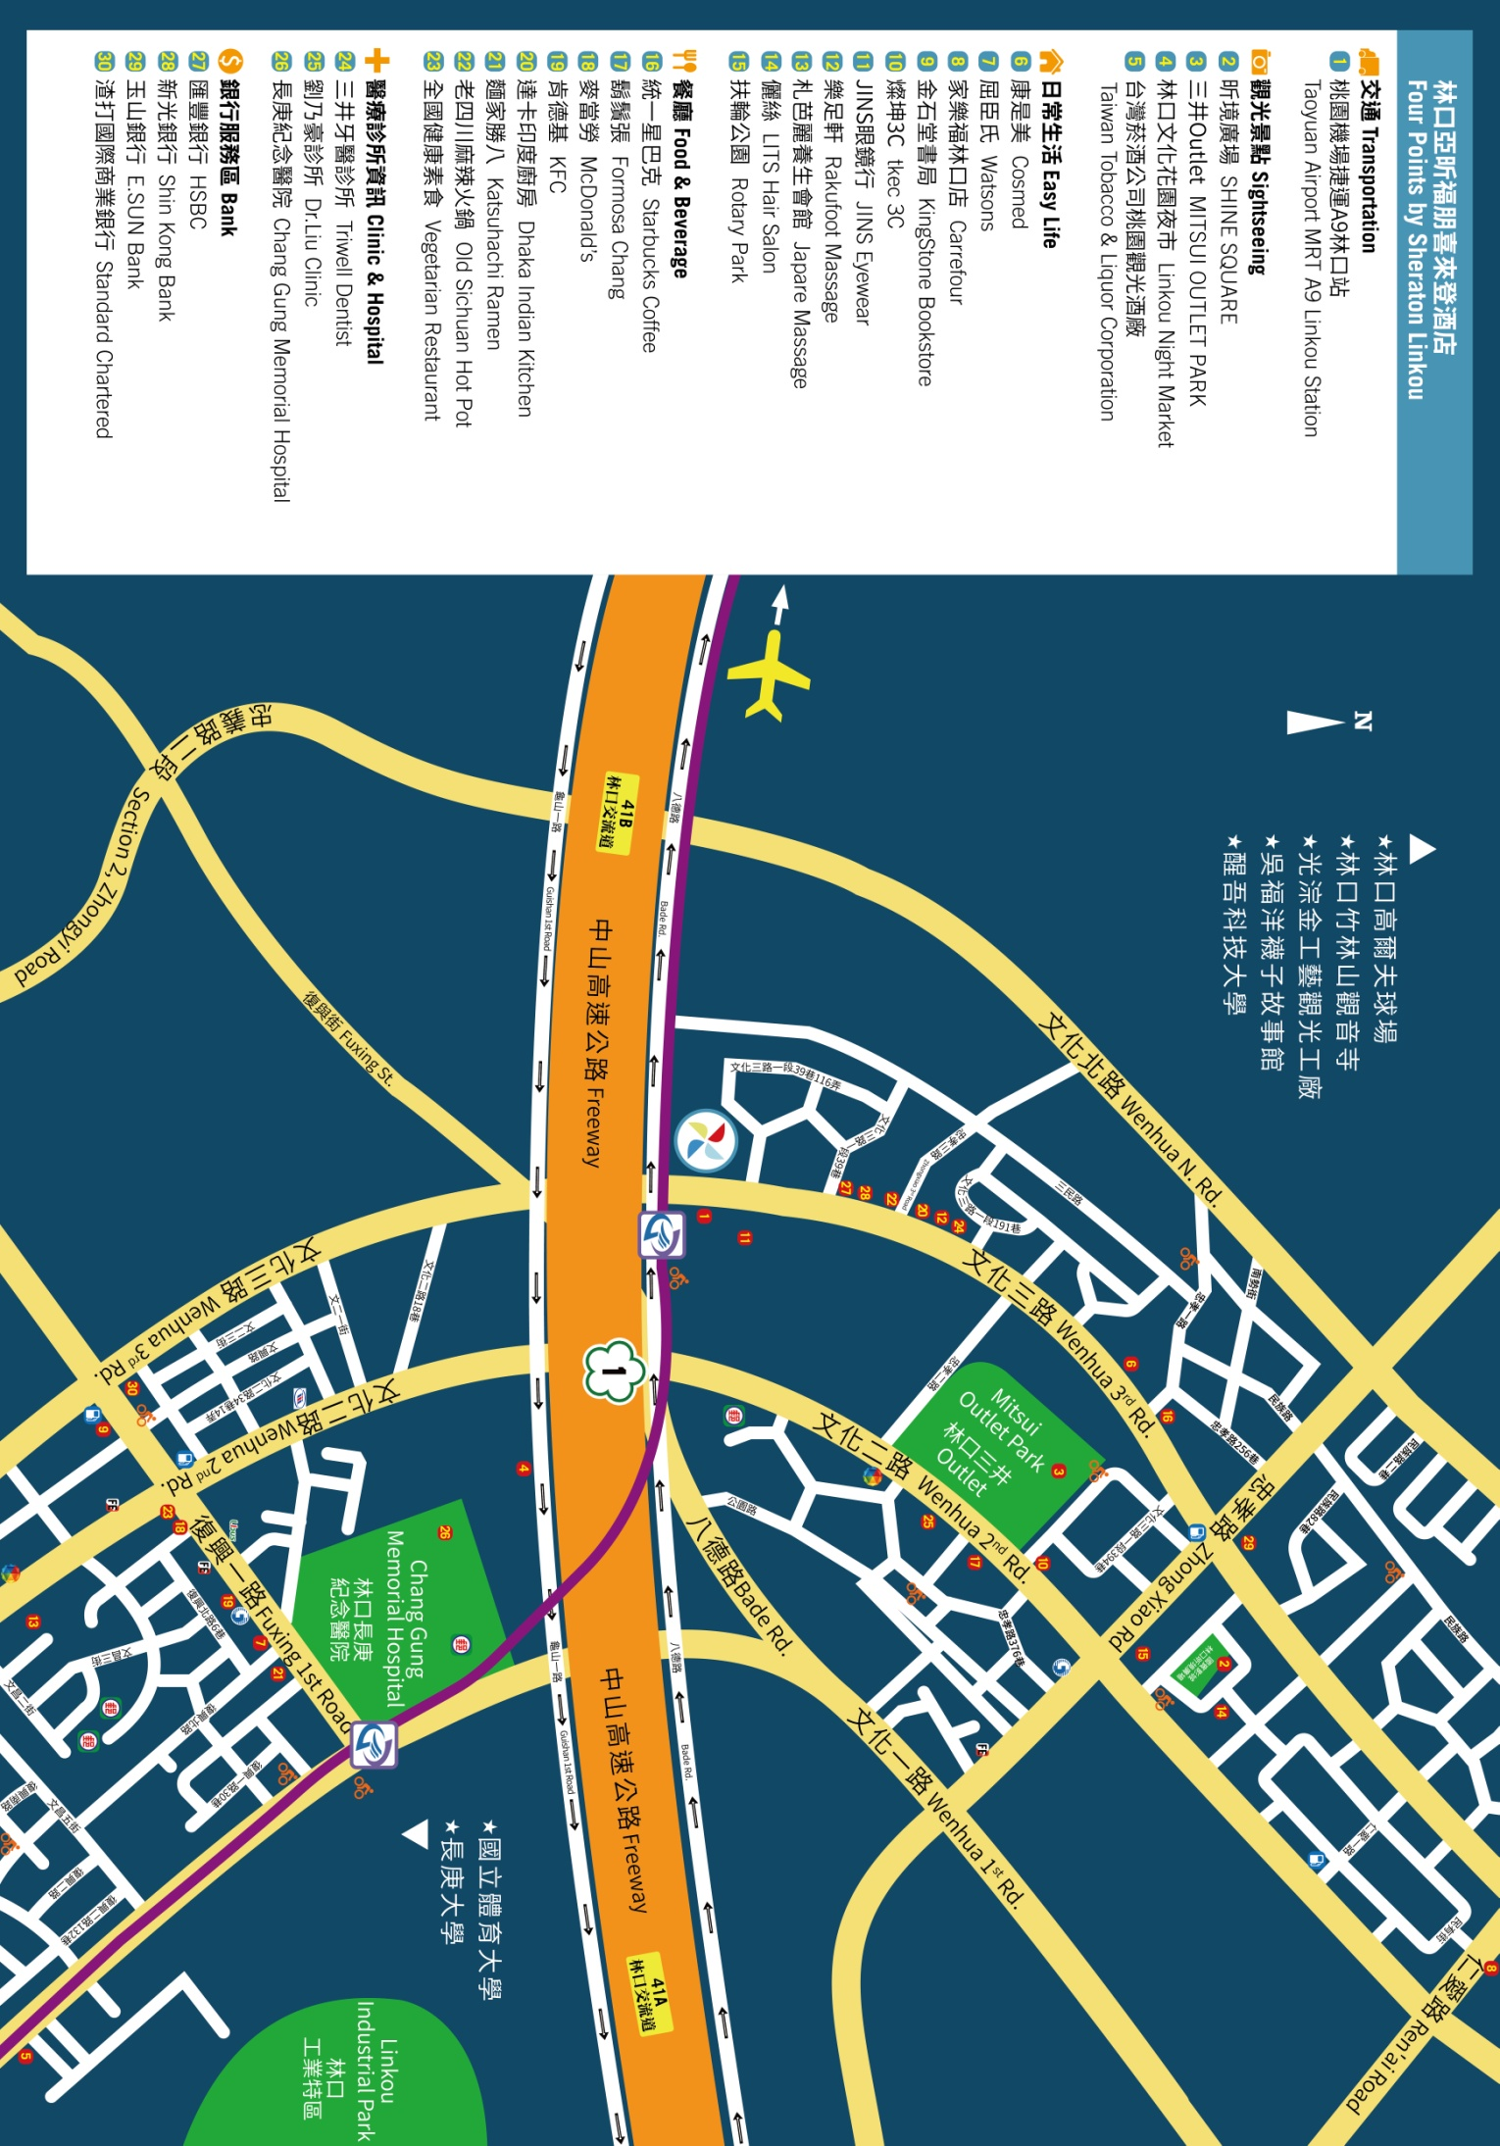
3. Taoyuan City Tour (大桃園區觀光)
利用大眾運輸工具(桃園機場捷運、火車、巴士)，暢遊大桃園地區!!
Let’s go around Taoyuan City by using public transportations ( train, bus and MRT).

･Shopping Mall
華泰名品城(Gloria Outlets)
捷運：桃園機場捷運線－A18高鐵桃園站
MRT：Taoyuan Airport MRT – A18 Taoyuan HSR Station
桃園市中壢區春德路189號
No. 189, Chunde Rd., Zhongli Dist., Taoyuan City
TEL: +886 3 273 8666
https://www.gloriaoutlets.com/chi/
Famous Outlet Shopping Mall.
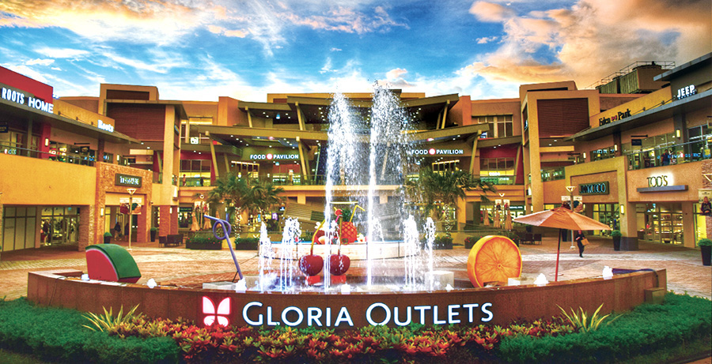
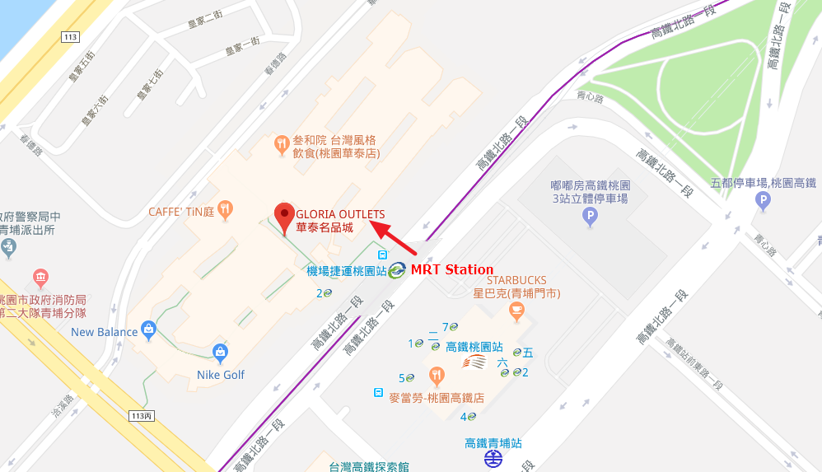

･SPORTS
桃園國際棒球場(Taoyuan International Baseball Stadium)
捷運：桃園機場捷運線－A19桃園體育園區
MRT：Taoyuan Airport MRT – A19 Taoyuan Sports Park
桃園市中壢區領航北路一段1號
No. 1, Sec. 1, Linghang N. Rd., Zhongli Dist., Taoyuan City
TEL: +886 3 425 0927
http://panosensing.com/moi_lamigo/
Baseball is the National Sports in Taiwan. The Play-Off Game of Taiwan Baseball League will be held in Oct. Welcome to enjoy our national baseball game!!
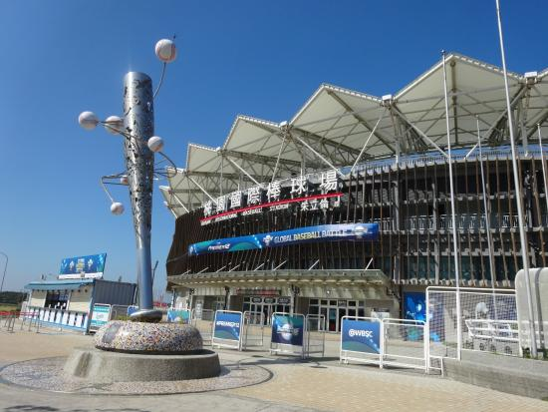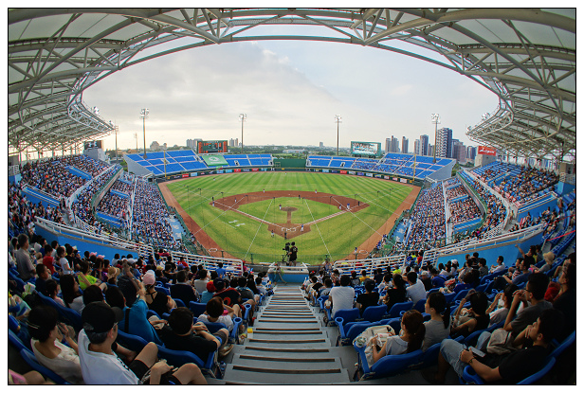
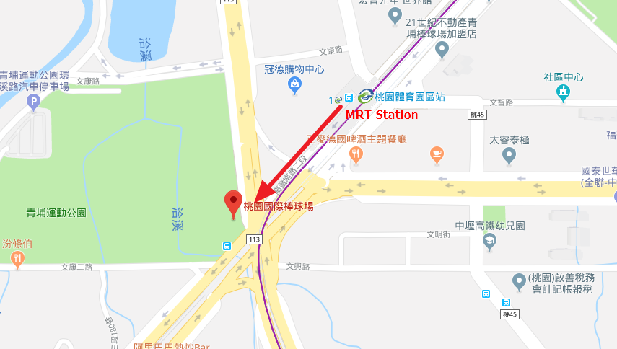

◎桃園市區(Downtown of Taoyuan City)

自飯店搭乘巴士至桃園巴士站，美食、伴手禮隨處可得!!

巴士：飯店步行至長庚醫院，搭乘2003線，抵達桃園巴士站

Take Bus to Taoyuan Bus Station to enjoy local foods, souvenir, shopping……etc.

~Walk from hotel to “Chang Gung Hospital”, take bus route “2003” to Taoyuan Bus Station.

･Foods & Souvenir
龍情花生菓鋪(Lung Ching Peanuts Shop)
桃園市桃園區中正路1號2樓(桃園火車站)
2F., No. 1, Zhongzheng Rd., Taoyuan Dist., Taoyuan City(Taoyuan train station)
TEL: +886 3 367 1141
http://www.lung-ching.com.tw/index.asp
Famous peanut candy in Taiwan. Peanut’s cake, egg roll is great, too.
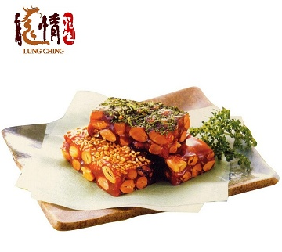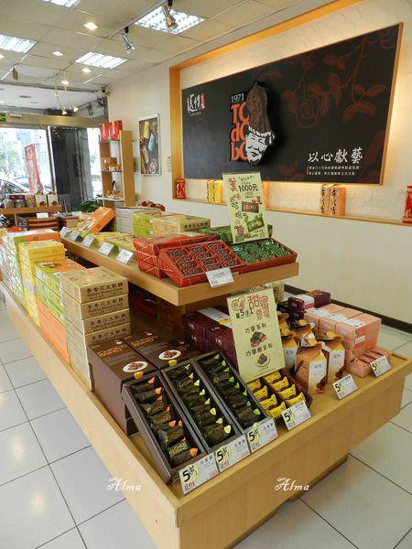
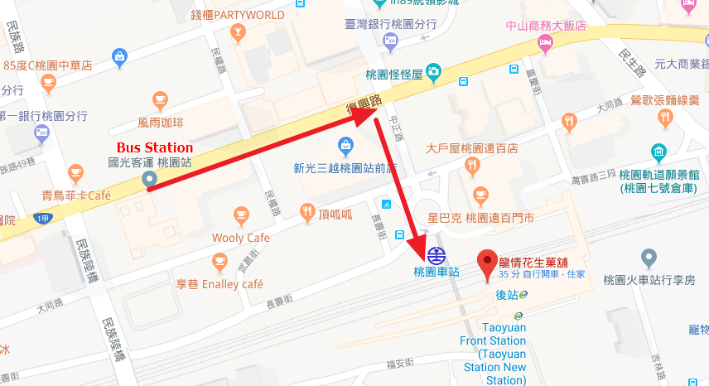

中崎本鋪(Nakasaki)
桃園市桃園區中山路56號
No. 56, Zhongshan Rd., Taoyuan Dist., Taoyuan City
TEL: +886 3 332 2480
http://www.nakasaki.com.tw/index.html
Famous Cake Shop in Taoyuan, over 80 year’s history.
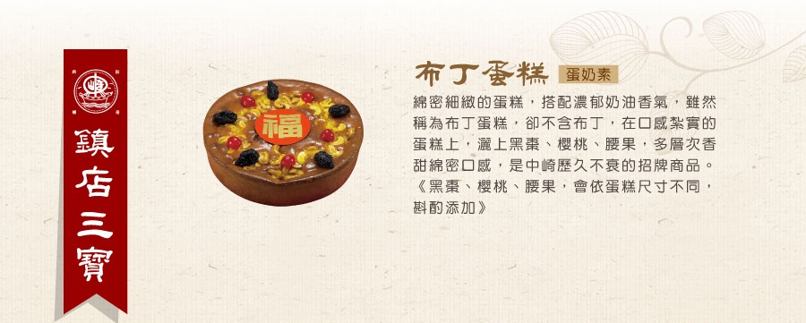
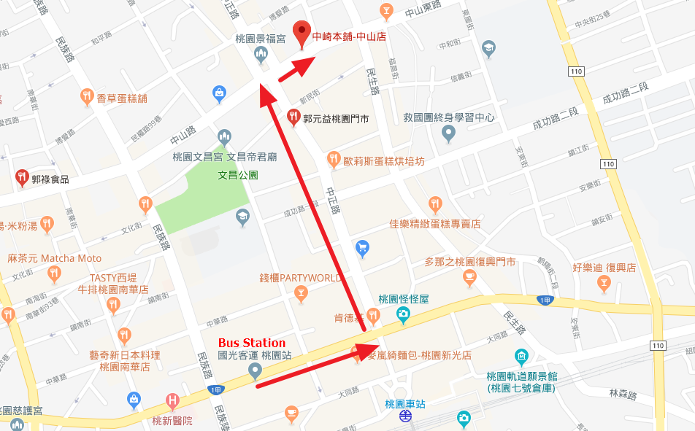

･Famous Foods and Snacks
健民潤餅店(Taiwanese Burrito)
桃園市桃園區民權路104號
No. 104, Minquan Rd., Taoyuan Dist., Taoyuan City
TEL: +886 3 332 4313
Traditional Taiwan food.
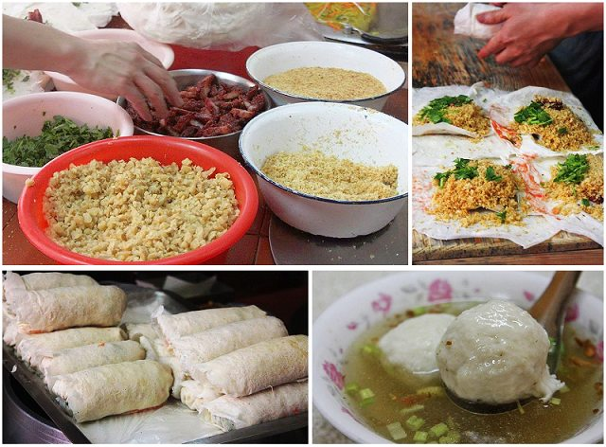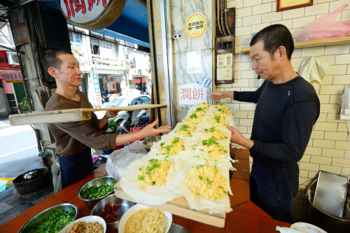 | 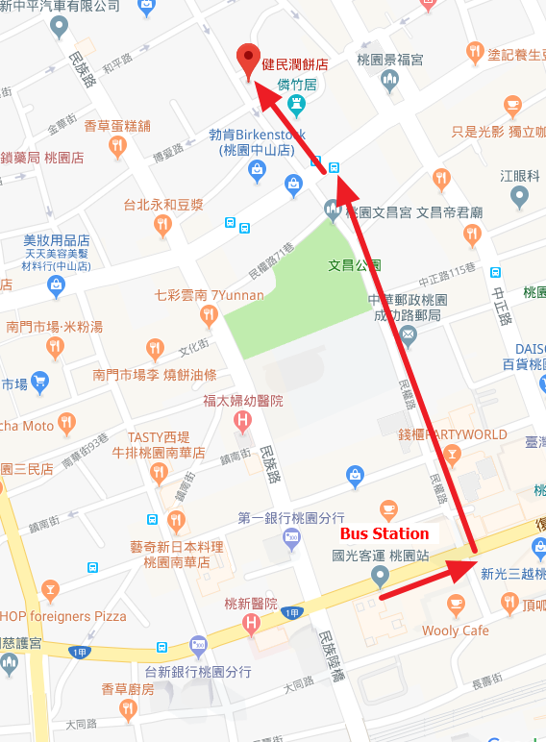

塗記養生豆花綠豆湯(Tu-Chi Tofu Pudding)
桃園市桃園區中山路45號
No. 45, Zhongshan Rd., Taoyuan Dist., Taoyuan City
TEL: +886 3 337 8077
Famous hand made tofu pudding with peanut or bubble.
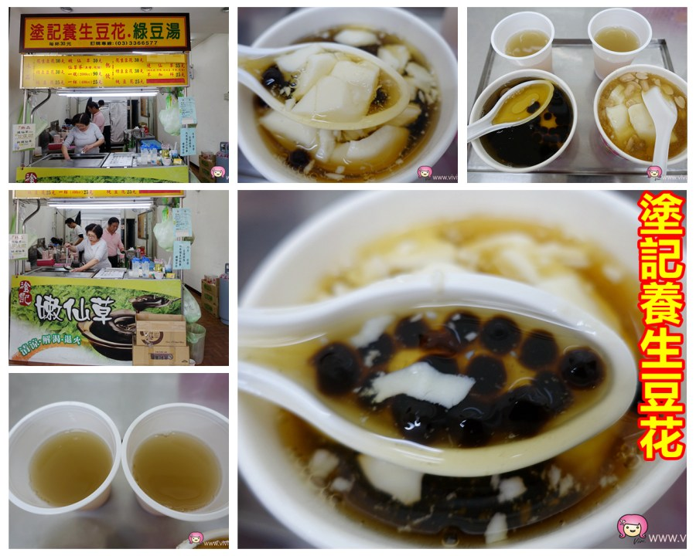 | 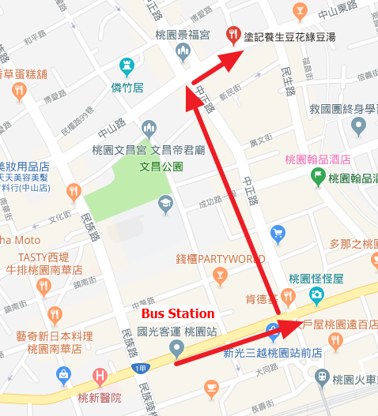

廟後瓜仔肉飯(Braised Pork Rice)
330桃園市桃園區中正路222號
No. 222, Zhongzheng Rd., Taoyuan Dist., Taoyuan City
TEL: +886 955 027 725
Traditional Taiwan Braised Pork Rice.
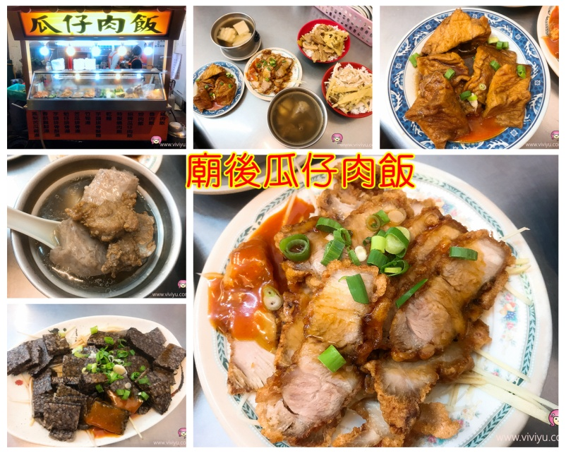 | 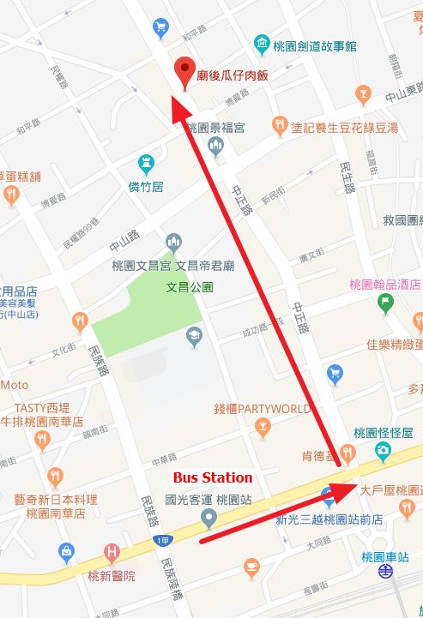

Taoyuan Airport MRT Map (桃園機場捷運路線圖)
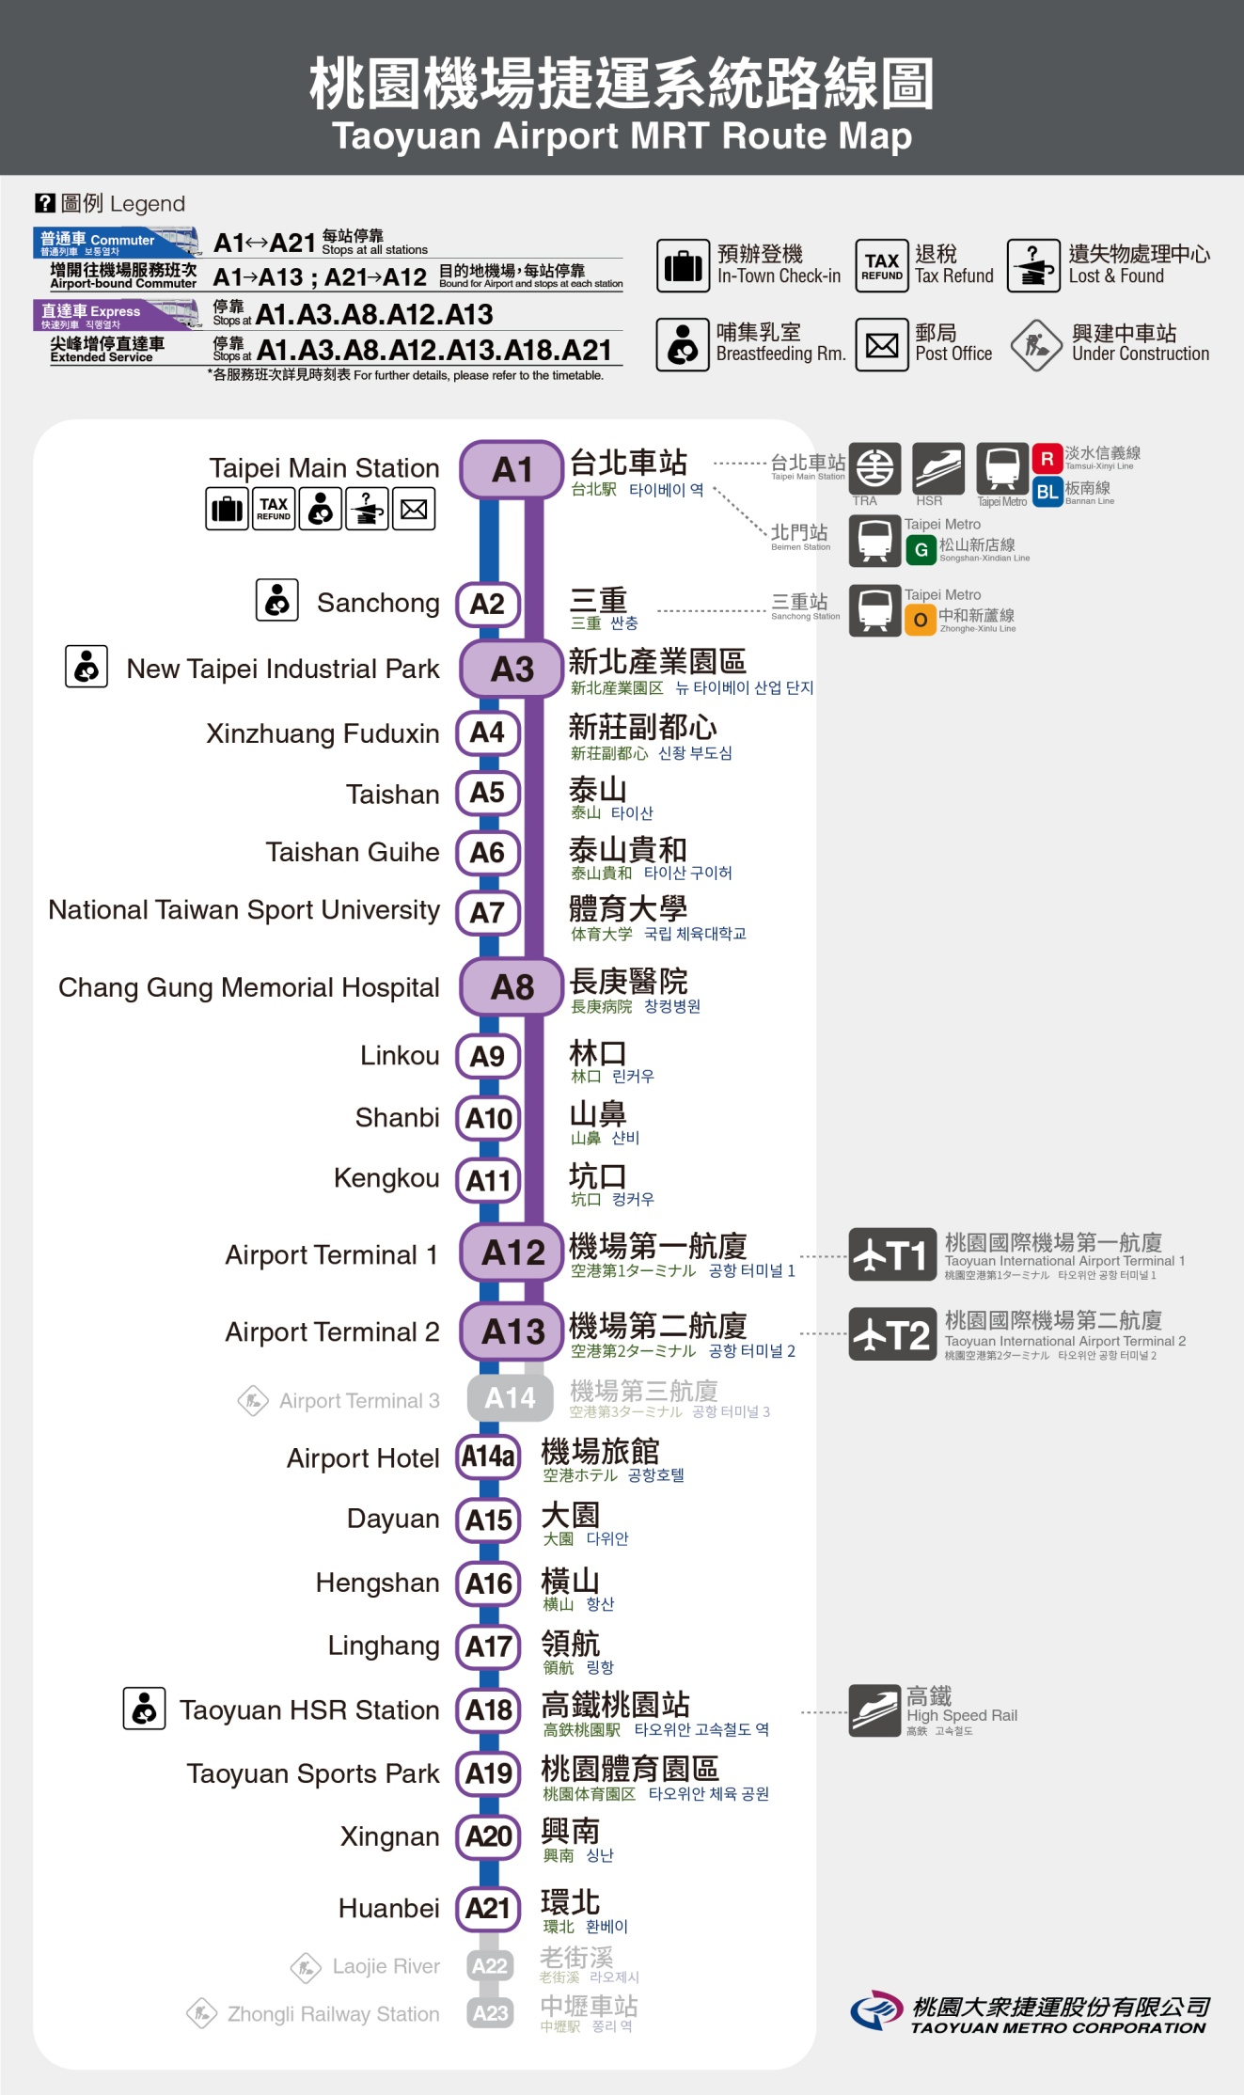

4. Taipei City Tour (台北觀光)
遊覽大台北地區，最方便的莫過於使用便利的台北捷運系統，幾乎是無處不達!!
The best way to travel all around Taipei City is using MRT.

･Restaurant Recommend
- 鼎泰豐(Din Tai Fung)
台北捷運：橘線－東門站
Taipei MRT：Orange Line-Dongmen Station
台北市大安區信義路二段194號
No.194, Sec. 2, Xinyi Rd., Da’an Dist., Taipei City
TEL: +886 2 2321 8928
http://dintaifungusa.com/zh-hant/
World Famous Taiwan’s Dumplings, remember to make reservation.
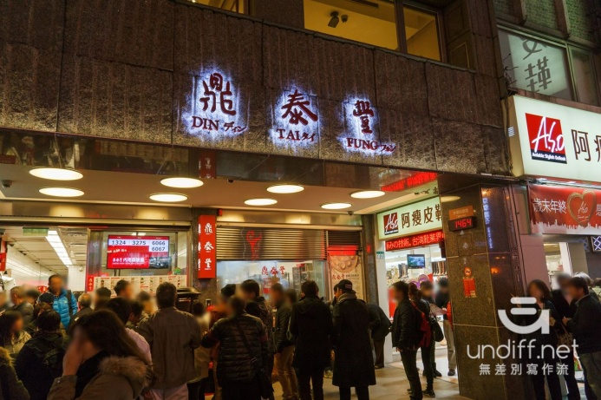  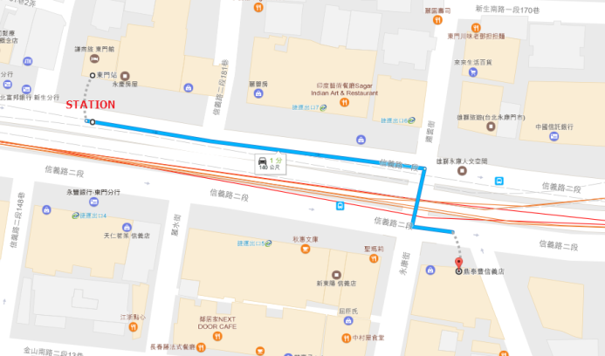 | 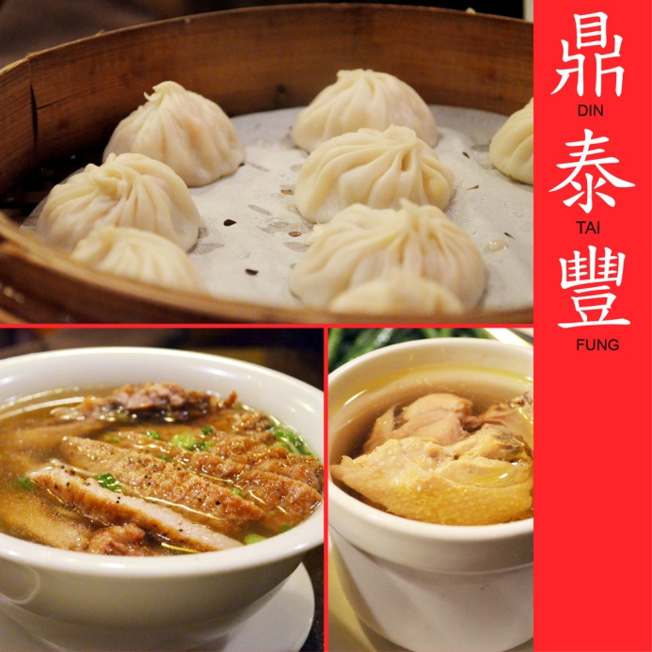

- 馬辣西門店(Mala Spicy Hot Pot)
台北捷運：藍線－西門站
Taipei MRT：Blue Line-Ximen Station
台北市萬華區西寧南路62號2樓
2F., No.62, Xining S. Rd., Wanhua Dist., Taipei City
TEL: +886 2 2314 6528
http://www.mala-1.com.tw/location02.html
Famous Spice Hot Pot, remember to make reservation.
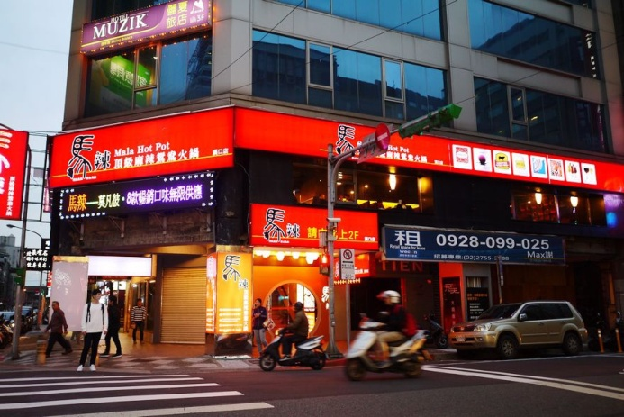 | 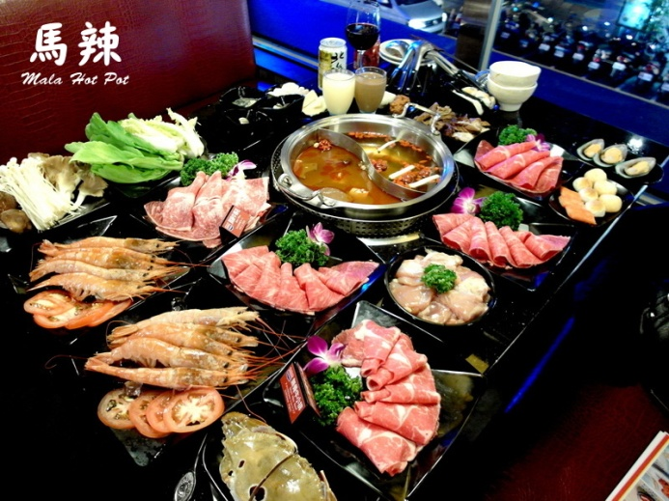
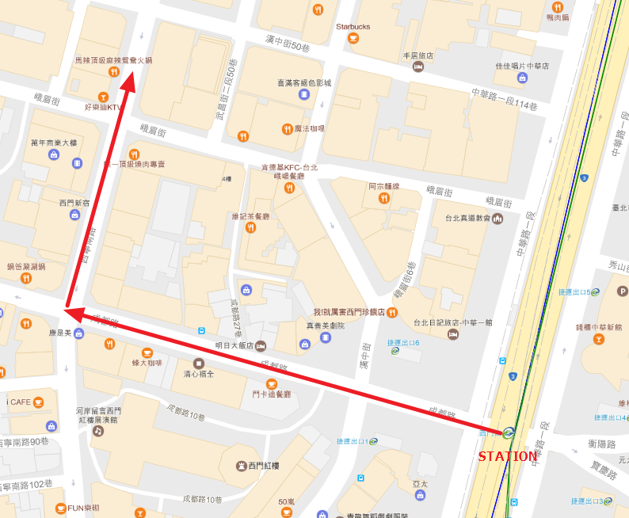

･Snacks and Souvenir
- 佳德鳳梨酥(Pineapple Pastry)
台北捷運：綠線－南京三民站
Taipei MRT：Green Line-Nanjing Sanmin Station
台北市松山區南京東路五段88號
No.88, Sec. 5, Nanjing E. Rd., Songshan Dist., Taipei City
TEL: +886 2 8787 8186
http://www.chiate88.com/
Most Famous Pineapple Pastry
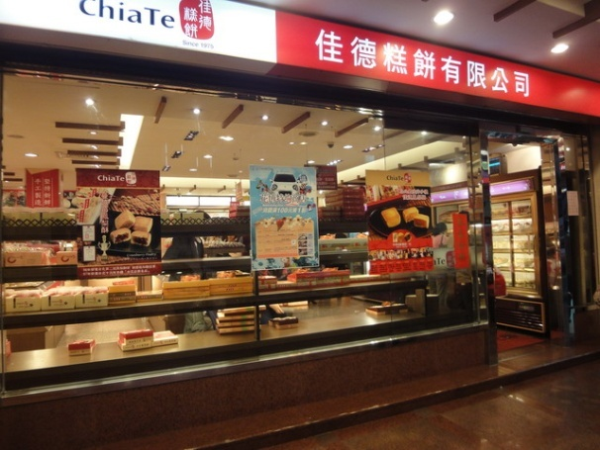 | 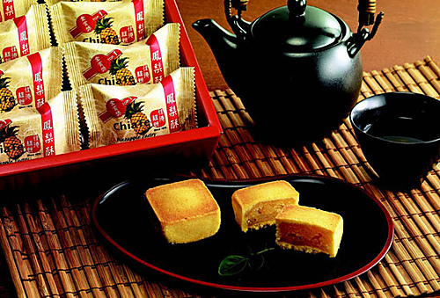
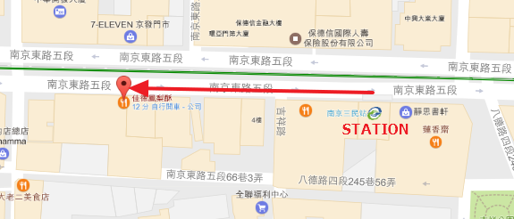

- 小林煎餅(Kobayashi Fried Cookie)
台北捷運：藍線－忠孝復興站
Taipei MRT：Blue Line-Zhongxiao Fuxing Station
台北市大安區忠孝東路四段94號
No.94, Sec. 4, Zhongxiao E. Rd., Da’an Dist., Taipei City
TEL: +886 2 2721 8909
http://www.xlcookie.com.tw/
Taiwan Style Cookie
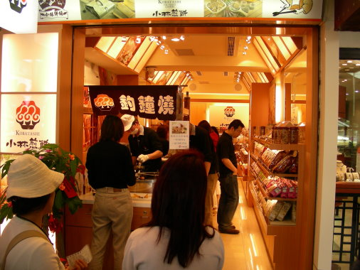 | 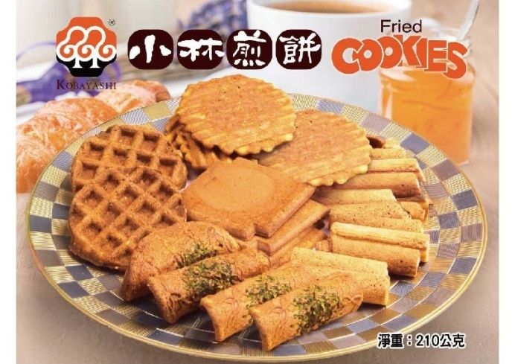
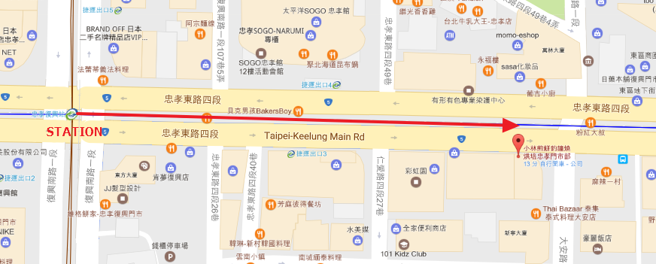

･Traditional Night Market (夜市)
士林夜市(Shilin Night Market)
台北捷運：紅線－劍潭站
Taipei MRT：Red Line-Jiantan Station
台北市士林區文林路43號
No.43, Wenlin Rd., Shilin Dist., Taipei City
All kind of local foods and snacks.
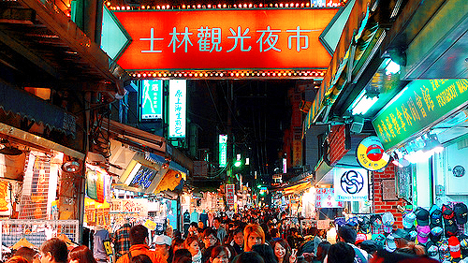 | 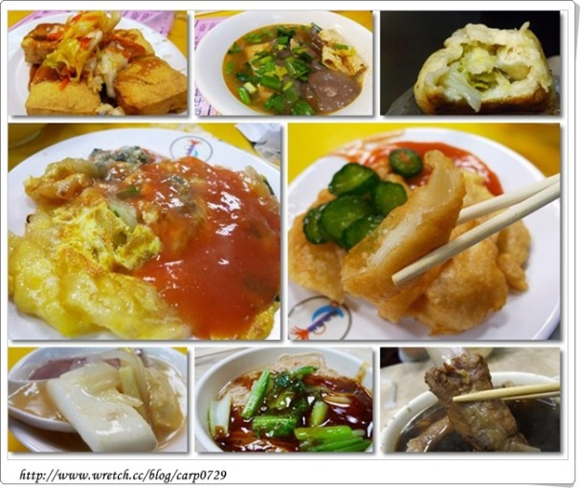

Taipei MRT Map (台北捷運路線圖)
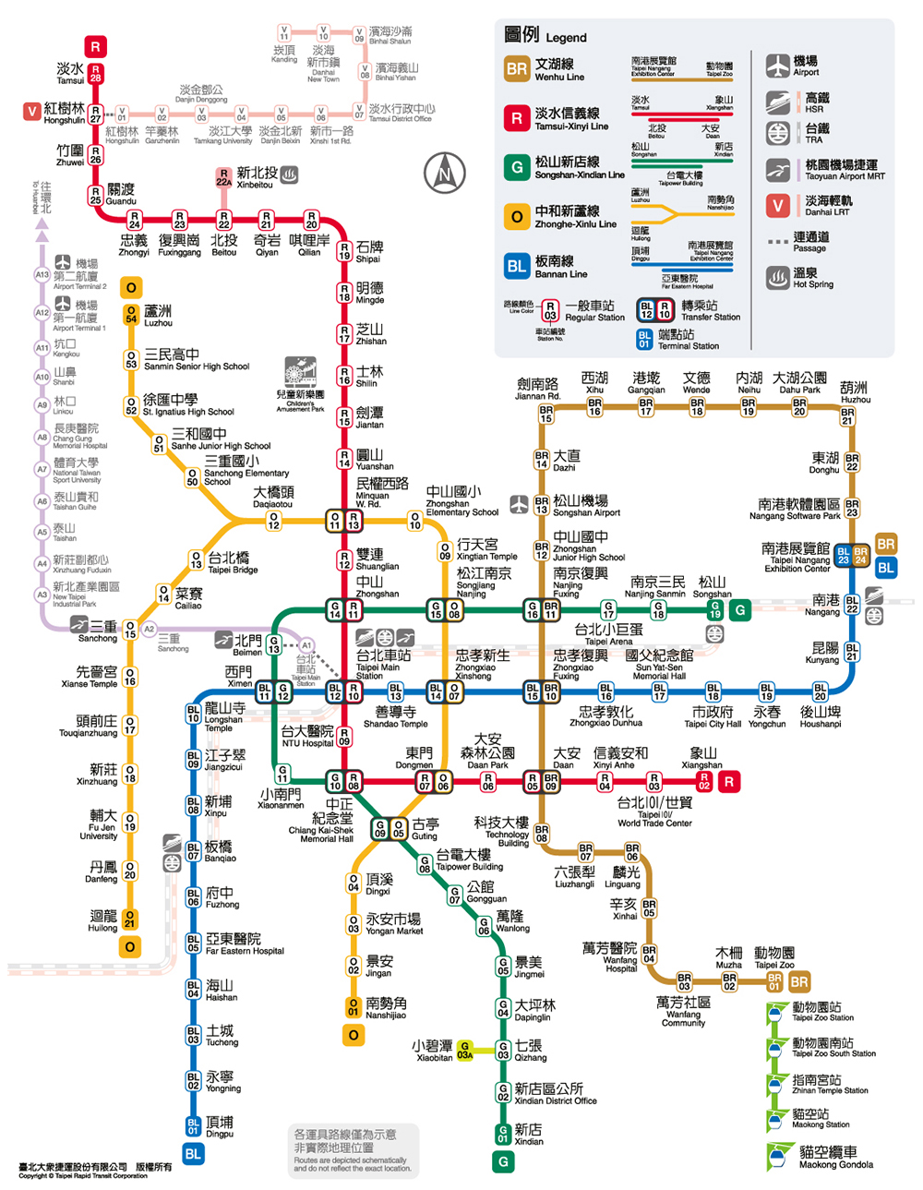

5. Dart Shop Information (鏢店資訊)
Name: 菁英撞球飛鏢休閒運動館 – Phoenix Dart 16
Address: 桃園縣平鎮區環南路二段265號B1
B1F., No. 265, Sec. 2, Huannan Rd., Pingzhen Dist., Taoyuan City

TEL: +886 3 428 8895
Machine: 6 | Accessories | Drink
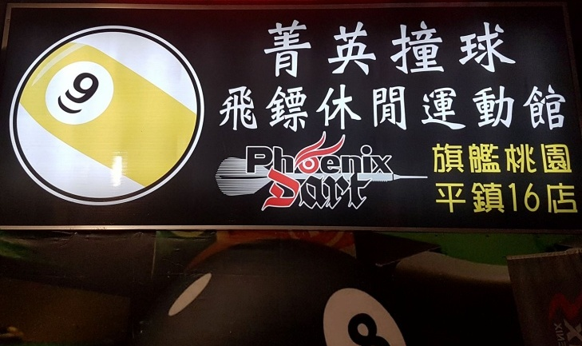 |  | 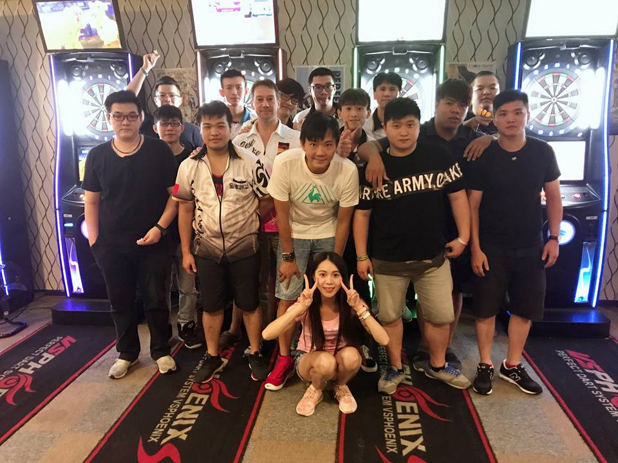

Name: 七號球館
Address: 桃園市桃園區中埔六街34巷33號
No. 33, Lane 34, Zhongpu 6th St., Taoyuan Dist., Taoyuan City
TEL: +886 3 356 0107
Machine: 5 | Accessories | Drink
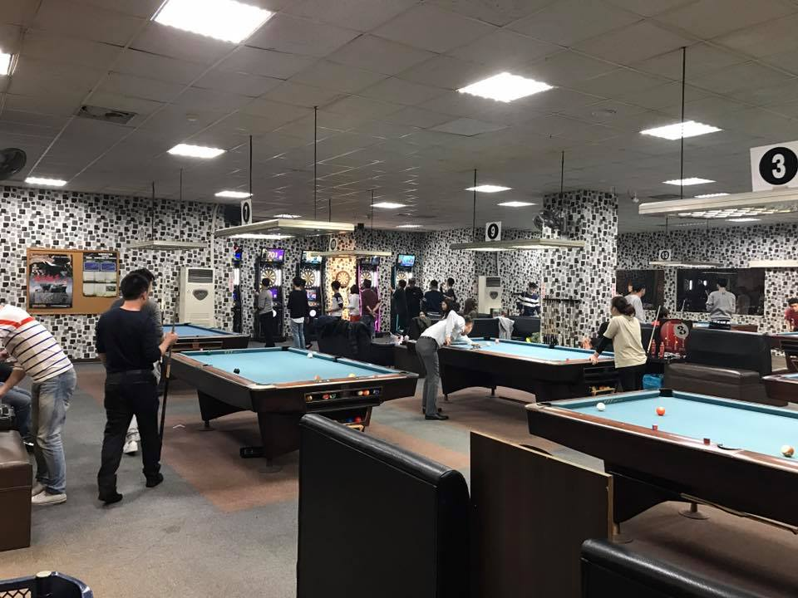 |  | 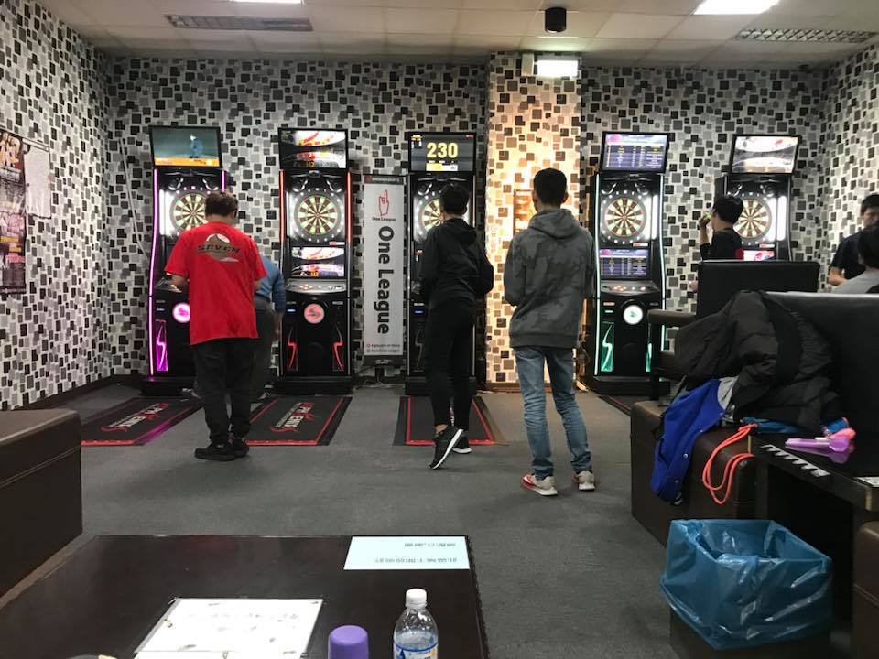

Name: 法愛音樂餐廳
Address: 桃園市桃園區民生路72號B1
B1F., No. 72, Minsheng Rd., Taoyuan Dist., Taoyuan City
TEL: +886 3 339 5979
Machine: 2 | Accessories | Drink | Food
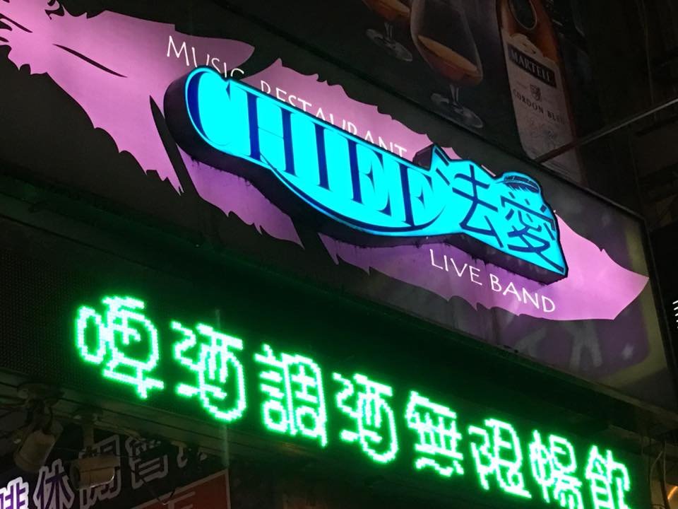 |  | 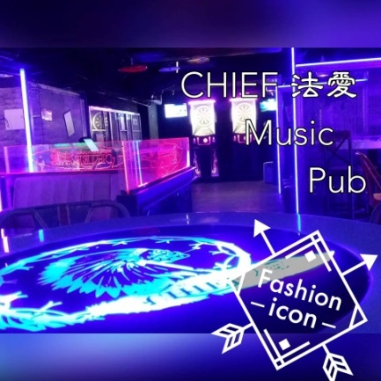

Name: C'est La Vie
Address: 桃園市中壢區大同路61號
No. 61, Datong Rd., Zhongli Dist., Taoyuan City
TEL: +886 970 638 589
Machine: 2 | Drink
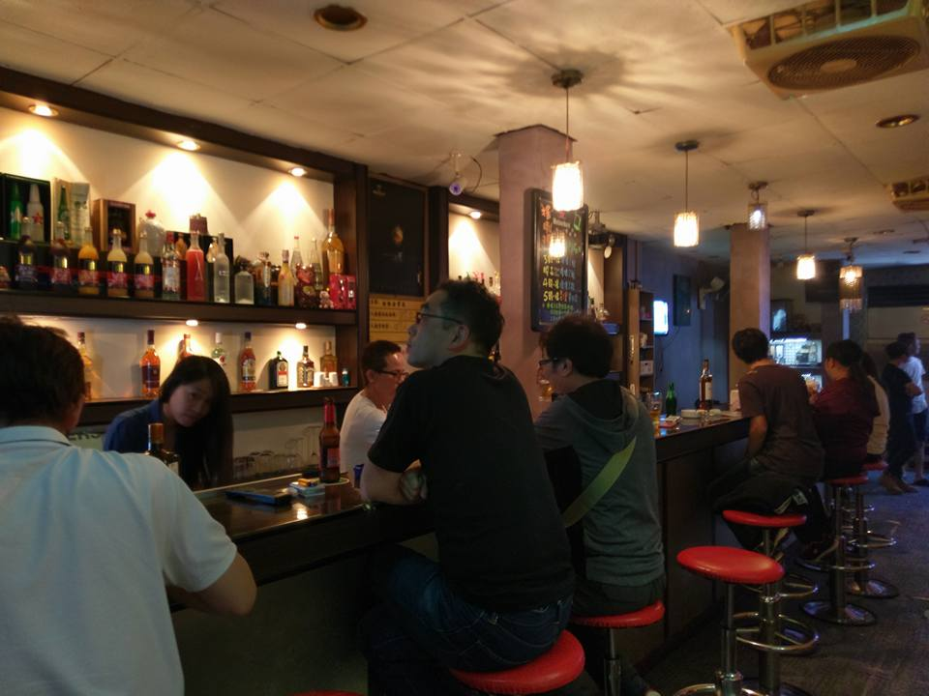 |  | 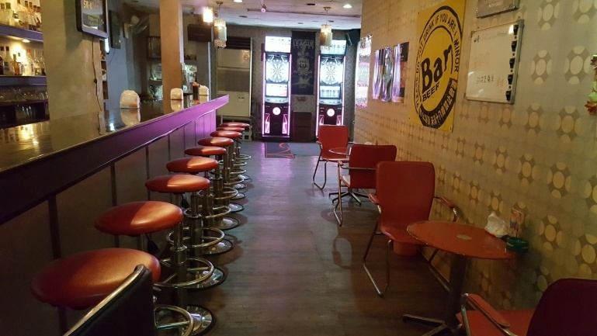

Name: 主場撞球
Address: 桃園市大園區中正東路306號2樓
2F., No. 306, Zhongzheng E. Rd., Dayuan Dist., Taoyuan City
TEL: +886 3 384 0822
Machine: 4 | Drink
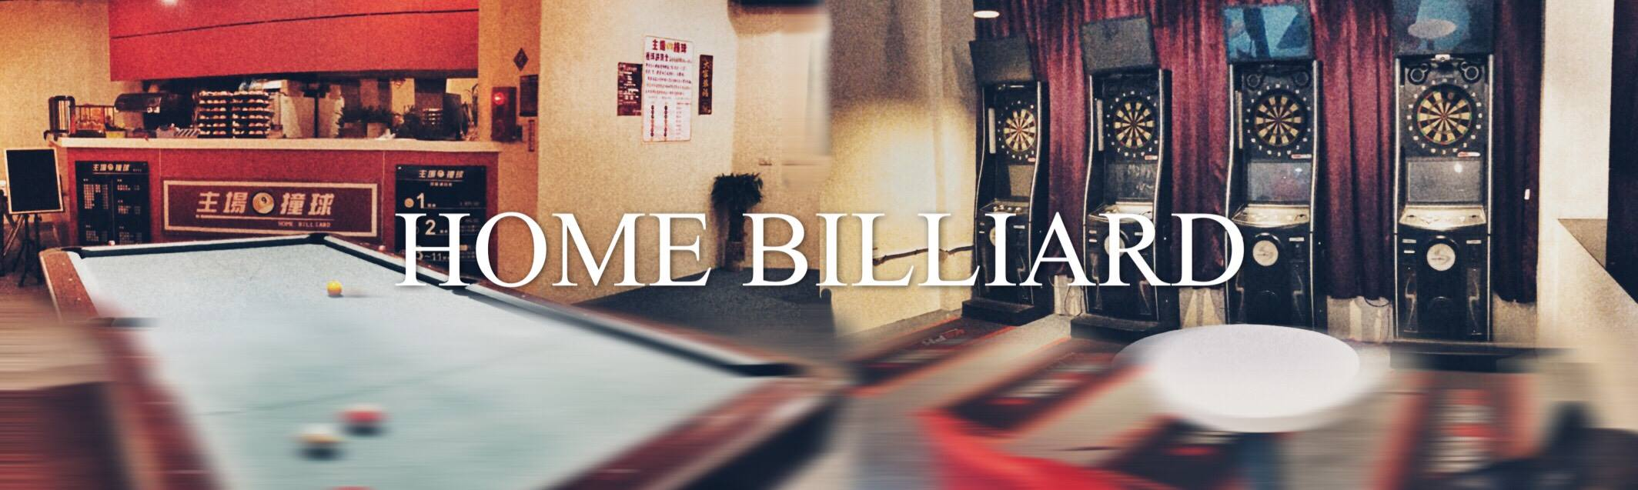

Name: 花酒臟Pub – Phoenix Dart 1
Address: 新北巿中和區成功路44號
No. 44, Chenggong Rd., Zhonghe Dist., New Taipei City
TEL: +886 2 8941 8126
Machine: 3 | Accessories | Drink | Food
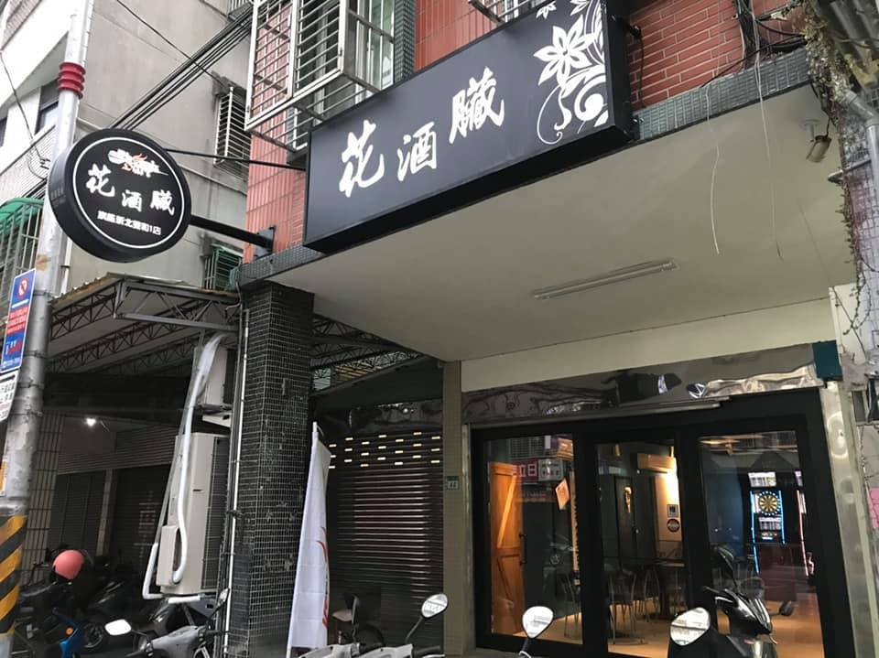 |  | 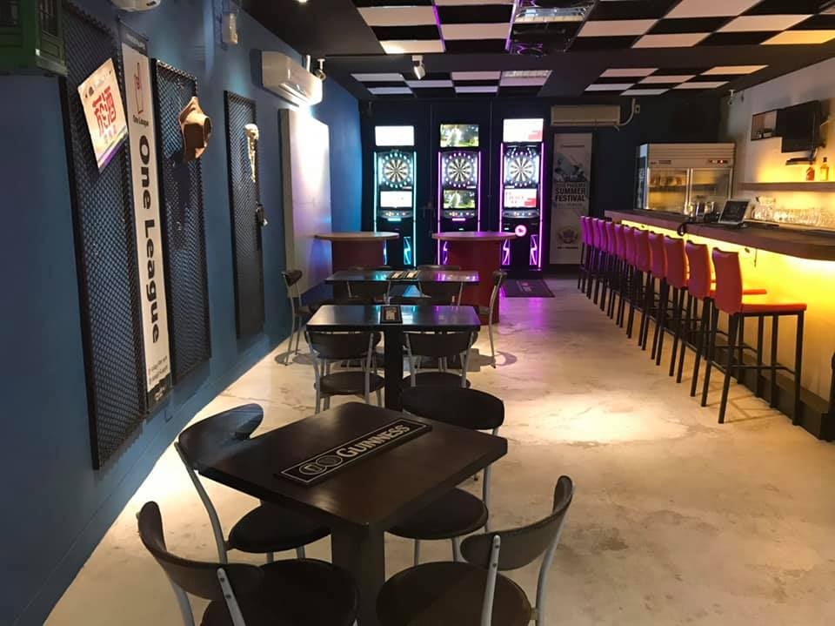

Name: 中原客棧 – Phoenix Dart 10
Address: 台北市松山區八德路四段182號
No.182, Sec. 4, Bade Rd., Songshan Dist., Taipei City
TEL: +886 2 2753 0077
Machine: 3 | Accessories | Drink | Food
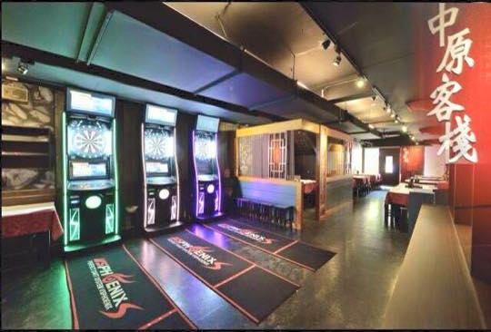 |  | 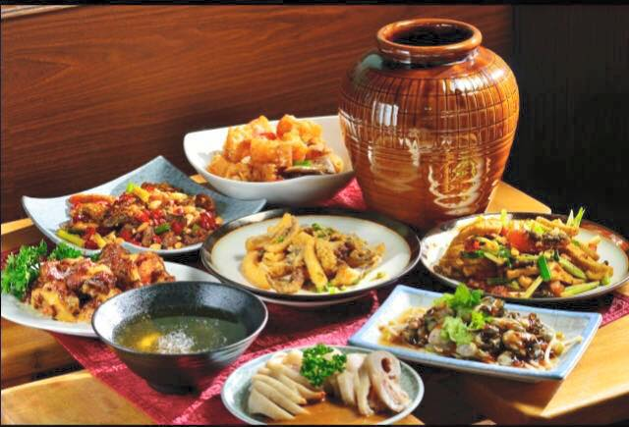

Name: 哈克飛鏢撞球運動館 – Phoenix Dart 12
Address: 新北市新店區北新路一段157號
No.157, Sec. 1, Beixin Rd., Xindian Dist., New Taipei City
TEL: +886 2 910 0762
Machine: 10 | Accessories | Drink | Snack
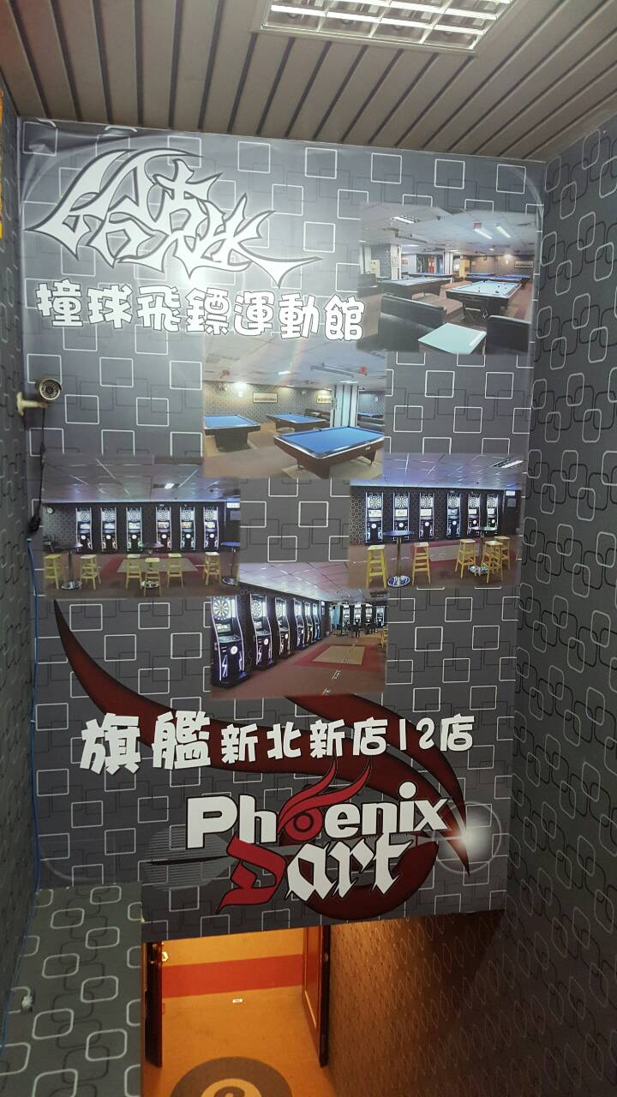 |  | 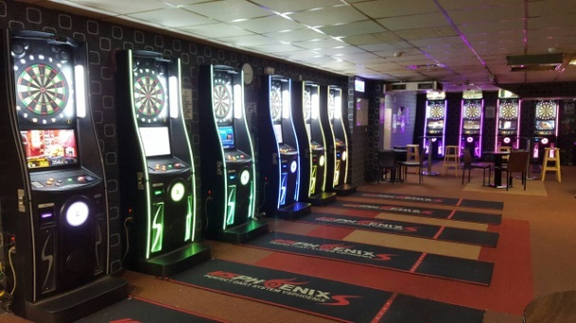

Name: Phoenix Dart 14 旗艦板橋14店
Address: 新北市板橋區雙十路二段6-4號
No.6-4, Sec. 2, Shuangshi Rd., Banqiao Dist., New Taipei City
TEL: +886 2 2250 0064
Machine: 9 | Accessories | Drink
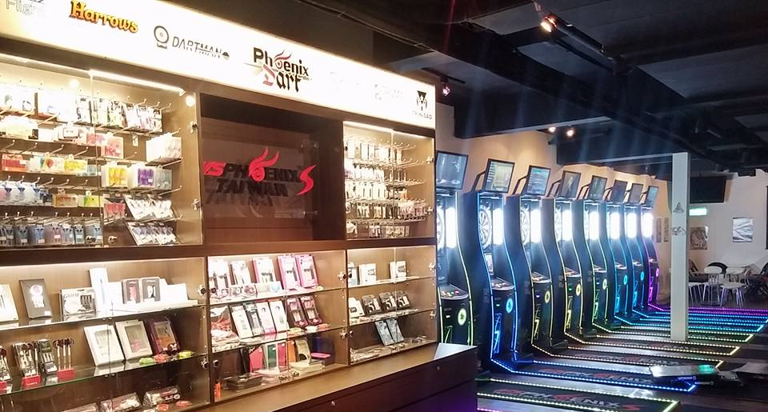 |  | 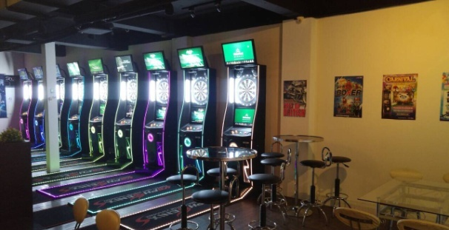

Name: Sense Bar - Phoenix Dart 18
Address: 新北市板橋區信義路31號
No.31, Xinyi Rd., Banqiao Dist., New Taipei City
TEL: +886 986 997 439
Machine: 7 | Accessories | Drink | Food
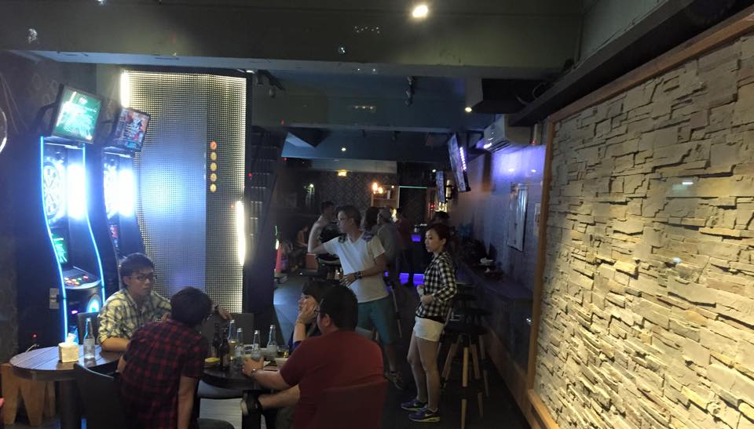 |  | 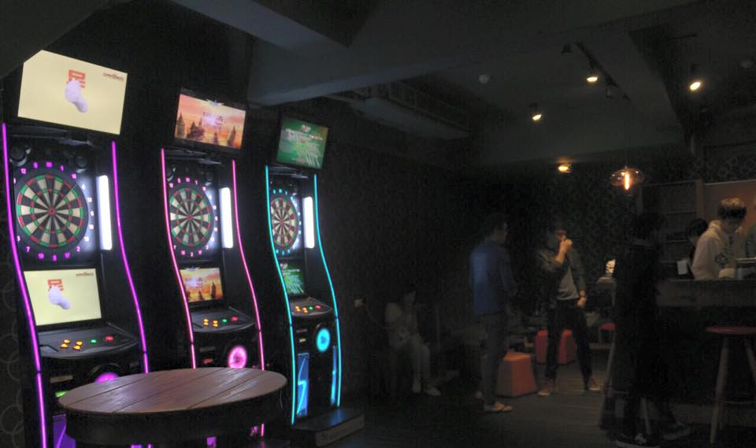

Name: Phoenix Dart 21 旗艦台北東區21店
Address: 台北市大安區敦化南路一段160巷25號
No.25, Lane 160, Sec. 1, Dunhua S. Rd., Da’an Dist., Taipei City
TEL: +886 2 8771 6962
Machine: 11 | Accessories | Drink | Snack
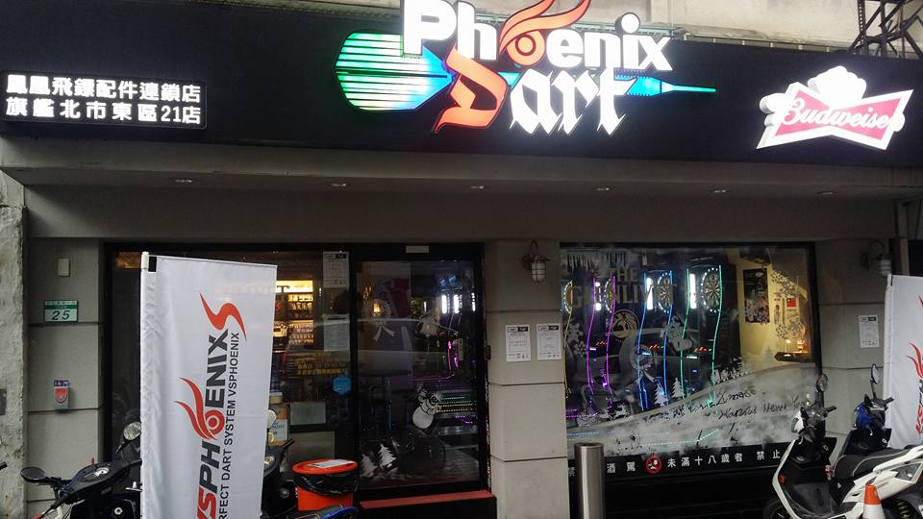 |  | 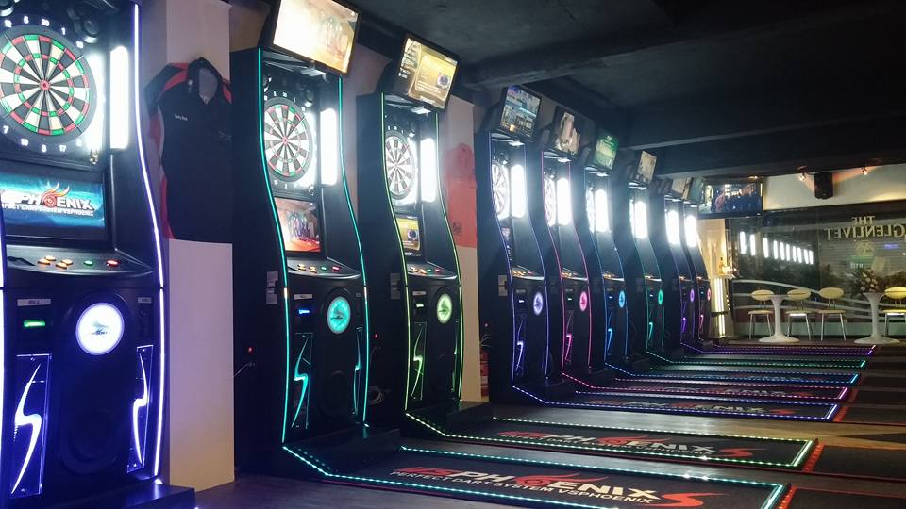

Name: Black Sheep Darts Studio – Phoenix Dart 23
Address: 新北市中和區中山路二段130號
No.130, Sec. 2, Zhongshan Rd., Zhonghe Dist., New Taipei City
TEL: +886 2 2242 5602
Machine: 8 | Accessories | Drink
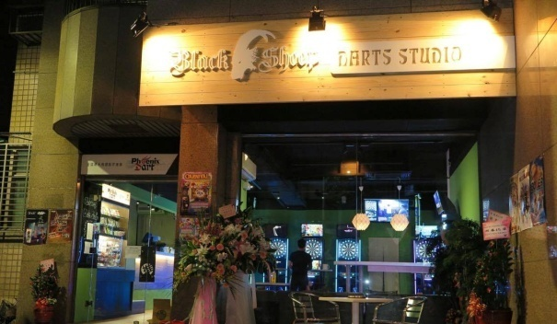 |  | 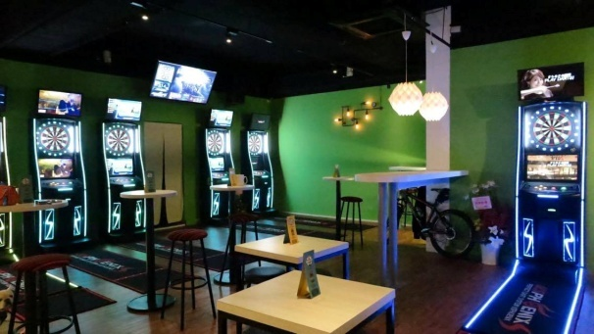

6. The 14th Taiwan Open on Google Map(QR Code)
點擊下方連結可在Google Map上查詢更多推薦地點
HOTEL
CHECK more restaurant and dart shop information on Google Map.
https://goo.gl/xaCMdZ
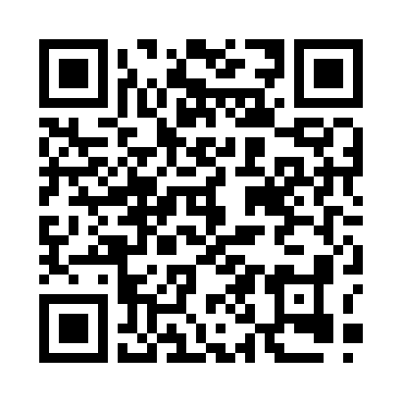
掃描QR Code可在Google Map上了解更多餐廳與鏢店資訊
Scan QR Code for more restaurant and dart shop information on Google Map

 | 林口亞昕福朋喜來登酒店  Four Points by Sheraton Linkou
 | Phoenix旗艦店  (Phoenix Dart Shop) | 
 | 飯店周邊餐廳、百貨公司  Restaurant and shopping mall near hotel
 | 商圈  Shopping area
 | 夜市與著名美食  Night market, Famous foods
鳳凰設置店
Darts Bar

